

System and Component Design v1.0

Group 4: Autonomous Foosball Table

|  |  |
| --- | --- |
| Ryan Ma | 1147335 |
| Chenhe Li | 1158035 |
| Taha Hussain | 1200349 |
| Viktor Smirnov | 1154392 |
| Roland Zhou | 1216063 |
| Alvin Li | 0957972 |

# **1 REVISIONS**

|  |  |  |  |
| --- | --- | --- | --- |
| Version | Date | Author | Description |
| 0 | Dec 6, 2015 | Ryan Ma,  Chenhe Li,  Taha Hussain,  Viktor Smirnov,  Roland Zhou,  Alvin Li | Initial version |
| 0.1 | Jan 17, 2016 | Chenhe Li | - add range column to Monitored Variables and Controller Variables table  - add secret hiding to software modules (9) |
| 0.1.1 | Jan 19, 2016 | Roland Zhou | - change Image processing behavior  - change Goal detection behavior  - add OpenCV library version number at Computer version (8.1.1) |
| 0.1.2 | Jan 20, 2016 | Ryan Ma,  Chenhe Li,  Taha Hussain,  Alvin Li | - hardware redesign |
| 0.1.3 | Mar 4, 2016 | Ryan Ma,  Chenhe Li,  Taha Hussain,  Roland Zhou,  Alvin Li | Update for new hardware design.  Improvement to controller and AI software |
| 0.2 | Mar 8, 2016 | Ryan Ma,  Chenhe Li | New rod connector design |
| 1.0 | Mar 12, 2016 | Ryan Ma,  Chenhe Li,  Taha Hussain | Updated format and styles  Added page numbers for list of tables and figures |

Table 1. Revisions

# **2 TABLE OF CONTENTS**

|  |  |
| --- | --- |
| 1 REVISIONS | 1 |
| 2 TABLE OF CONTENTS | 3 |
| 3 LIST OF TABLES | 6 |
| 4 LIST OF FIGURES | 7 |
| 5 INTRODUCTION | 9 |
| 5.1 Purpose | 9 |
| 5.2 Scope | 9 |
| 5.3 Background | 10 |
| 5.4 Roadmap | 10 |
| 5.5 Definitions and Abbreviations | 12 |
| 6 SYSTEM DESCRIPTION | 13 |
| 6.1 System Overview | 13 |
| 6.2 Monitored Variables | 15 |
| 6.3 Controlled Variables | 16 |
| 6.4 Constants | 16 |
| 7 BEHAVIOUR DESCRIPTION | 18 |
| 7.1 Behaviour Overview | 18 |
| 7.2 System Initialization | 18 |
| 7.3 System Operating State: | 19 |
| 7.4 System Shutdown: | 20 |
| 8 HARDWARE DESIGN | 21 |
| 8.1 Linear Motion | 21 |
| 8.1.1 Relevant Calculations | 22 |
| 8.2 Rotational Motion | 24 |
| 8.3 Motor Controller | 25 |
| 8.4 User Interface | 28 |
| 8.5 Computer Vision | 31 |
| 8.6 Hardware Cover | 32 |
| 8.6.1 Rod Protector | 32 |
| 8.6.2 Actuator Protector | 33 |
| 9 SOFTWARE DESIGN | 34 |
| 9.1 Computer Vision | 35 |
| 9.1.1 Image Processing: | 35 |
| 9.1.2 Ball Detection: | 37 |
| 9.1.3 Foosman Detection: | 38 |
| 9.1.4 Unknown Detection: | 40 |
| 9.1.5 Goal Detection: | 42 |
| 9.2 AI Opponent | 44 |
| 9.2.1 Trajectory Prediction: | 45 |
| 9.2.2 AI Actions: | 47 |
| 9.3 User Interface | 48 |
| 9.3.1 LCD Display: | 49 |
| 9.3.2 User inputs: | 50 |
| 9.4 Safety Validation | 52 |
| 9.5 Motor Controller | 53 |
| 9.5.1 MIS(Module interface Specification) | 54 |
| 9.5.2 Motor Control: | 54 |
| 9.5.3 PC Communication: | 56 |
| 9.5.4 Initialization: | 57 |
| 9.5.5 MID - Module Interface Design | 58 |
| 9.5.6 Module Name - Motor Control | 60 |
| 9.5.6.1 Move_Motor | 60 |
| 9.5.6.2 Distance_to_NeededSteps | 61 |
| 9.5.6.3 Angle_to_NeededSteps | 62 |
| 9.5.6.4 Home_Motors | 62 |
| 9.5.7 Module Name : PC Communication | 62 |
| 9.5.7.1 PC_Receive | 63 |
| 9.5.8 Module name : Initialization | 63 |
| 9.5.8.1 Stepper_Pin_Config() | 63 |
| 9.5.8.2 Serial_Config() | 63 |
| 9.5.8.3 Homing_Config() | 63 |
| 9.5.8.4 STOP_RESET_Config() | 63 |
| 10 SCHEDULING | 64 |
| 11 UNDESIRED EVENT HANDLING | 65 |
| 12 NORMAL OPERATION | 66 |
| 13 DESIGNS THAT ARE LIKELY TO CHANGE | 67 |
| 14 DESIGNS THAT ARE NOT LIKELY TO CHANGE | 68 |
| 15 APPENDIX A. COLOR SPACE: | 69 |
| 15.1 RGB color space: | 69 |
| 15.2 HSV color space: | 69 |
| 15.3 Convert from RGB to HSV: | 70 |
| 16 APPENDIX B. HARDWARE LIST | 71 |
| 17 APPENDIX C. FIGURE LIST | 73 |

# **3 LIST OF TABLES**

|  |  |
| --- | --- |
| Table 1. Revisions | 2 |
| Table 2. Definitions and Abbreviations | 12 |
| Table 3. Monitored Variables | 15 |
| Table 4. Controller Variables | 16 |
| Table 5. Constants | 17 |
| Table 6. Linear Motion Hardware | 22 |
| Table 7. Rotational Motion and Power supply | 24 |
| Table 8. Motor Controller | 28 |
| Table 9. User Interface | 31 |
| Table 10. Undesired Event Handling | 65 |
| Table 11. Normal Operations | 66 |
| Table 12. Designs That Are Likely to Change | 67 |
| Table 13. Designs That Are Not Likely to Change | 68 |
| Table 14. Hardware List | 72 |

# 

# 

# **4 LIST OF FIGURES**

|  |  |
| --- | --- |
| Figure 1. Roadmap | 11 |
| Figure 2. System Hardware Overview | 13 |
| Figure 3. System Overview | 14 |
| Figure 4. Context diagram | 14 |
| Figure 5. Behavior Overview Diagram | 18 |
| Figure 6. States transition diagram | 20 |
| Figure 7. Belt Driven V-Slot Linear Actuator | 21 |
| Figure 8 . Arduino and RAMP 1.4 interface with stepper control | 26 |
| Figure 9. Schematic of the switches for STOP,RESET and 2 homing switches for the linear motors | 27 |
| Figure 10. The 2004 LCD Control Board and Arduino Mega Board | 30 |
| Figure 11. Camera Stand(A) and Camera Stand Dimensions(B) | 32 |
| Figure 12. Rod Protector Dimension | 33 |
| Figure 13. Modular Decomposition | 34 |
| Figure 14. AI Class Diagram | 44 |
| Figure 15. HSV Color space | 70 |
| Figure 16. V-Slot Rail | 73 |
| Figure 17. V-Slot Gantry Set | 73 |
| Figure 18. Nema 17 Stepper Motor | 74 |
| Figure 19. GT2 Timing Belt | 74 |
| Figure 20. GT2 Timing Pulley | 75 |
| Figure 21. Micro Limit Switch (with mounting plate) | 75 |
| Figure 22. SUNSKY S-360-12 Power Supply | 76 |
| Figure 23. Nema 16 Stepper Motor | 76 |
| Figure 24. Flexible Helical Coupling | 77 |
| Figure 25. Arduino Mega | 77 |
| Figure 26. RAMPS 1.4 Stepper Motor Shield | 78 |
| Figure 27. A4988 Stepper Motor Driver | 79 |
| Figure 28. 2004 LCD Control Board | 79 |
| Figure 29. Mini Pushbutton Switch | 80 |
| Figure 30. PLAYSTATION Eye™ | 80 |
| Figure 31. LM2596 DC-DC converter | 81 |
| Figure 32.BUZ73AH N-Mosfet | 81 |
| Figure 33. Nema 17 Stepper Motor Mount | 82 |

# 

# 

# **5 INTRODUCTION**

## **5.1 Purpose**

The purpose of this document is to describe the initial design for each component of autonomous foosball table. It will be used as a reference throughout the development cycle, and will be built upon as the design progresses. The document will also act as a guide for later stages in the development process

The project involves design, development and verification of an autonomous robot capable of playing foosball against a human opponent.

## **5.2 Scope**

The focus of this component design document is to specify the hardware and software that will be used for implementation of the autonomous foosball table. Components within the system will be defined though the modular interface specifications and modular internal design. This document will be used as a reference and guide to keep track of the successive development steps to ensure the system is designed and implemented in accordance with the performance and functionality goals.

This project is constructing a retrofit/extension of a mini foosball table by employing software, electronic and mechanical methods. The entire design and implementation of mini foosball table is not within the scope of the project.

The system includes the following functionalities:

● Awareness of game start event

● Defence (blocking) against high­ speed foosball

● Offence (foosball handling and shooting) where possible

● Stopping the game based on user input

● Edge case detection and handling

● Human Machine Interface

● Unknown detection

● Goal detection

The following functionalities are deemed to be out of scope:

● Resetting the foosball after goal

● Resetting the foosball after dead ball (the foosball has completely stopped its motion and is not within reach of any player figure)

● Resetting the foosball stuck on user foosball men reachable area

● Detecting user spinning the rod

## **5.3 Background**

The autonomous foosball table is a foosball table that offers a robotic opponent which can challenge human players. It allows one to play foosball without the need of finding another human opponent and play with AI on different difficulty levels.

## **5.4 Roadmap**

Figure 1 below is the roadmap for this project. (For detailed version click this [link](https://docs.google.com/spreadsheets/d/1D8vNFgQwGkfuoN6klKOyD6agbPdgBtAi7UDL9EPomso/edit?usp=sharing) )

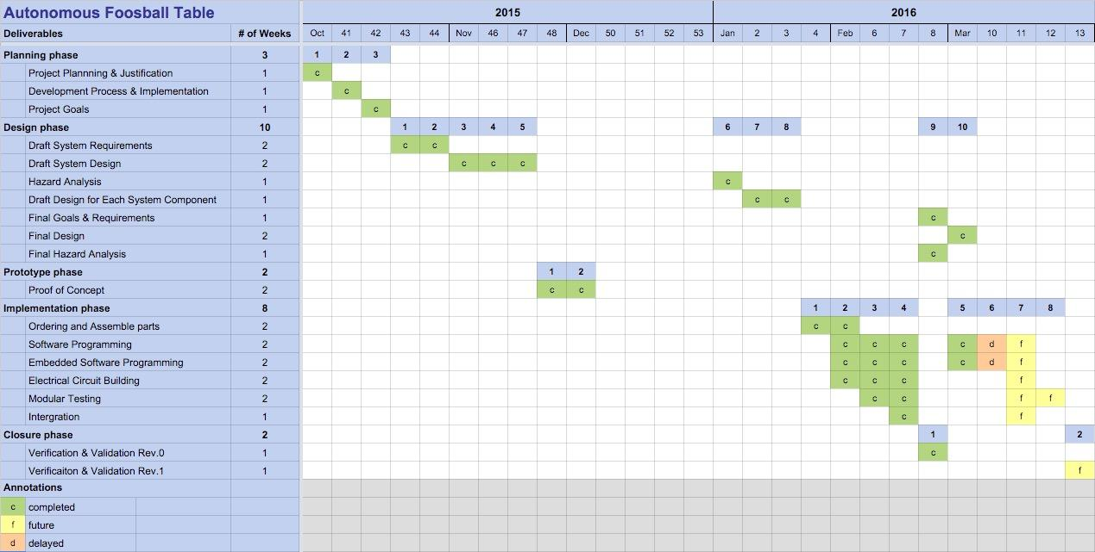

## **5.5** **Definitions and Abbreviations**

|  |  |
| --- | --- |
| **Term** | **Definition** |
| foosball table | The autonomous mini foosball table |
| foosman | The players in the foosball table |
| ball | The ball used in the game |
| point | a tuple of float x,float y |
| user | The user playing the autonomous foosball table |
| row1 | System controlled center foosball man on offense side rod (robot goalkeeper) |
| row2 | System controlled center foosball man on defense side rod (robot fieldplayer) |
| enemy1 | User controlled foosball center man on offense side rod (enemy goalkeeper) |
| enemy2 | User controlled center foosball man on defense side rod (enemy fieldplayer) |
| webcam | Sony PLAYSTATION Eye**™** camera uses as input hardware device in computer vision. The frame which it captures is in RGB color space. It can achieve up to 75 fps at 640x480 pixels, or 120 fps at 320x240 pixels. |
| RGB | RGB color space constructs all the colors from the combination of the Red,Green and Blue colors. The red, green and blue use 8 bits each, which have integer values from 0 to 255. Detail explanation is in 15.1. |
| HSV | HSV color space constructs all the color based on three components: hue, saturation and value. Detail explanation is in 15.2. |

**Table 2.** Definitions and Abbreviations

# **6 SYSTEM DESCRIPTION**

## **6.1 System Overview**

Figure 2 below gives a general overview of the hardware and software components of the system respectively. Some of the major hardware parts in the system include a computer, an Arduino Mega 2560 controller with a RepRap Arduino Mega Pololu Shield, a PS3 Eye webcam and four stepper motors. Machine vision, AI actions and safety validation will be processed by a software program running on a computer.

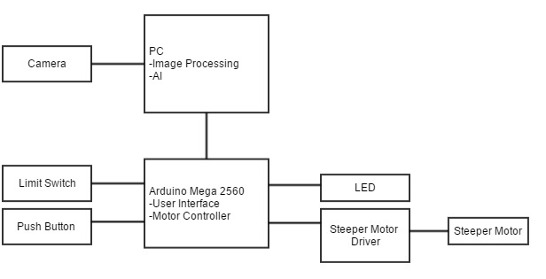

**Figure 2**. System Hardware Overview

PS3 Eye webcam is directly connected to the computer and computer vision software module processes the image. The AI software module analyzes the output from computer vision module and determines the best actions for rod controlling robot. Motor controller module takes the position and speed inputs and controls stepper motor. User input are processed by user interface module in the microcontroller. The microcontroller and the computer communicate through a serial communication device. The overall system is updated with a frequency of 60Hz due to the limitation of image processing speed of the system.

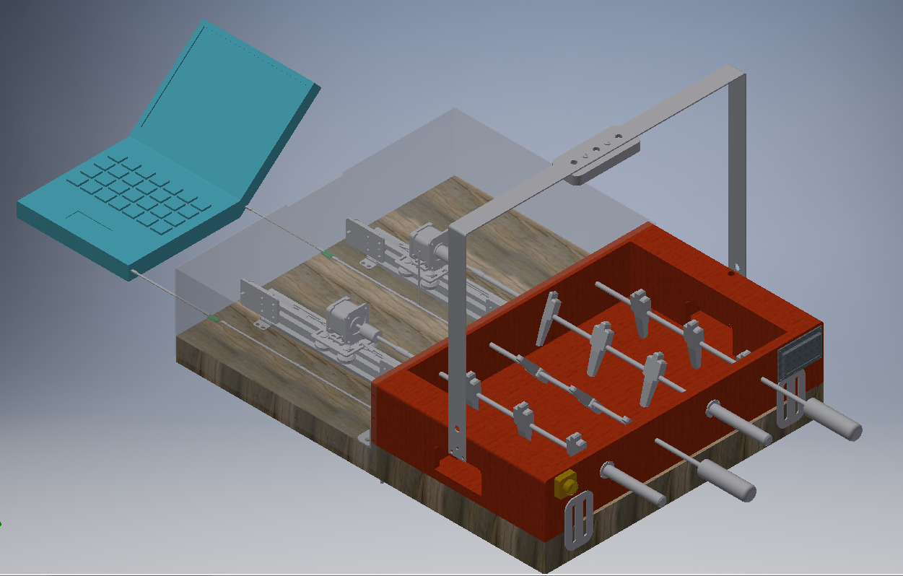

**Figure 3.** System Overview

The context diagram below (Figure 4) gives a general idea of the system inputs and outputs.

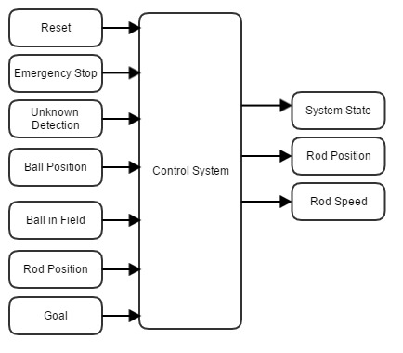

**Figure 4.** Context diagram

## **6.2** **Monitored Variables**

|  |  |  |  |
| --- | --- | --- | --- |
| **Variable** | **Range** | **Units** | **Description** |
| m_unknown_object | Binary | - | Other objects show in the foosball table |
| m_ball_x | 0 - 400 | mm | Position of the foosball in the x-axis |
| m_ball_y | 0 - 288 | mm | Position of the foosball in the y-axis |
| m_row1_lp | 95 - 190 | mm | Linear position of the center foosman in row 1 |
| m_row2_lp | 95 - 190 | mm | Linear position of the center foosman in row 2 |
| m_enemy1_lp | 95 - 190 | mm | Linear position of the center foosman in enemy 1 |
| m_enemy2_lp | 95 - 190 | mm | Linear position of the center foosman in enemy 2 |
| m_row1_ap | -180 - 180 | degree | Angular position of the center foosman in row 1 |
| m_row2_ap | -180 - 180 | degree | Angular position of the center foosman in row 2 |
| m_enemy1_ap | -180 - 180 | degree | Angular position of the center foosman in enemy 1 |
| m_enemy2_ap | -180 - 180 | degree | Angular position of the center foosman in enemy 2 |
| m_safety | Binary | - | Safety shutdown button |
| m_reset | Binary | - | Reset button |
| m_difficulty_select | 0, 1, 2 | - | User requests difficulty level |
| m_ball_found | Binary | - | Check if find ball in field |
| m_goal_user | Binary | - | Check if user get goal |
| m_goal_robot | Binary | - | Check if robot get goal |

**Table 3.** Monitored Variables

## **6.3** **Controlled Variables**

|  |  |  |  |
| --- | --- | --- | --- |
| **Variable** | **Range** | **Units** | **Description** |
| c_row1_lp | 95 - 190 | mm | Linear position of row 1 |
| c_row2_lp | 95 - 190 | mm | Linear position of row 2 |
| c_row1_ap | -180 - 180 | degree | Angular position of row 1 |
| c_row2_ap | -180 - 180 | degree | Angular position of row 2 |
| c_mode | 0, 1, 2 | - | System mode; 0 for waiting, 1 for gameplay, 2 for emergency mode |
| c_gameplay | 0,1 | - | gameplay mode; 0 for defence mode, 1 for offence mode |

**Table 4.** Controller Variables

## 

## 

## **6.4** **Constants**

|  |  |  |  |
| --- | --- | --- | --- |
| **Constant** | **Value** | **Units** | **Description** |
| k_field_length | 400 | mm | Length of the foosball field |
| k_field_width | 288 | mm | Width of the foosball field |
| k_ball_diameter | 28 | mm | Diameter of the foosball |
| k_max_linear_range | 95 | mm | Linear movement range of the row |
| k_goal_width | 85 | mm | Width of the goal |
| k_goal_length | 40 | mm | Length of the goal |
| k_foosman_height | 75 | mm | Height of the foosman |
| k_foosman_distance | 85 | mm | Distance between the centers of two foosmen |
| k_foosman_width | 13 | mm | Width of the bottom part of the foosman |
| k_cam_width | 320 | pixel | Width of the frames |
| k_cam_height | 240 | pixel | Height of the frames |
| k_edge_x_min | 20 | pixel | Minimum edge position in x-axis |
| k_edge_x_max | 304 | pixel | Maximum edge position in x-axis |
| k_edge_y_min | 18 | pixel | Minimum edge position in y-axis |
| k_edge_y_max | 220 | pixel | Maximum edge position in y-axis |
| k_row_1 | 55 | mm | row one x-axis |
| k_row_2 | 255 | mm | row two x-axis |
| k_enemy_1 | 155 | mm | human controlling row one x-axis |
| k_enemy_2 | 357 | mm | human controlling row two x-axis |

**Table 5.** Constants

# **7 BEHAVIOUR DESCRIPTION**

## **7.1 Behaviour Overview**

The behaviour of the system can be divided into behaviour of modules in the system and their sub-modules.

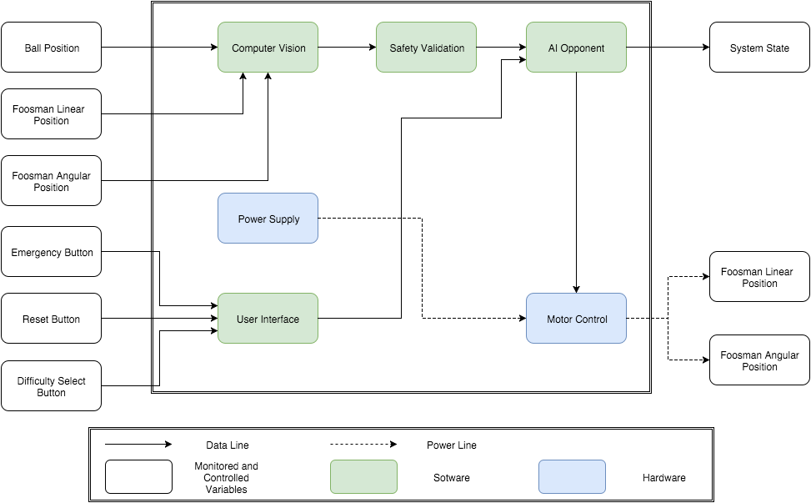

**Figure 5.** Behavior Overview Diagram

## **7.2 System Initialization**

To initialize the system, the following actions have to be done in the order that they are listed:

1. Start user program on pc
2. Power on motors
3. Press reset button on the foosball table to calibrate the foosmen positions

## **7.3 System Operating State:**

The autonomous foosball table has the following 3 states:

* **Wait Mode:** System waits for user to start the foosball game. All motors are calibrated to move the foosmen to homed positions linearly and angularly.
* **Game Mode:** System play against human player as a opponent.
* **Emergency Stop Mode:** All motors are stopped and unpowered.

The transitions between each state are shown in the diagram next page (Figure 6 ):

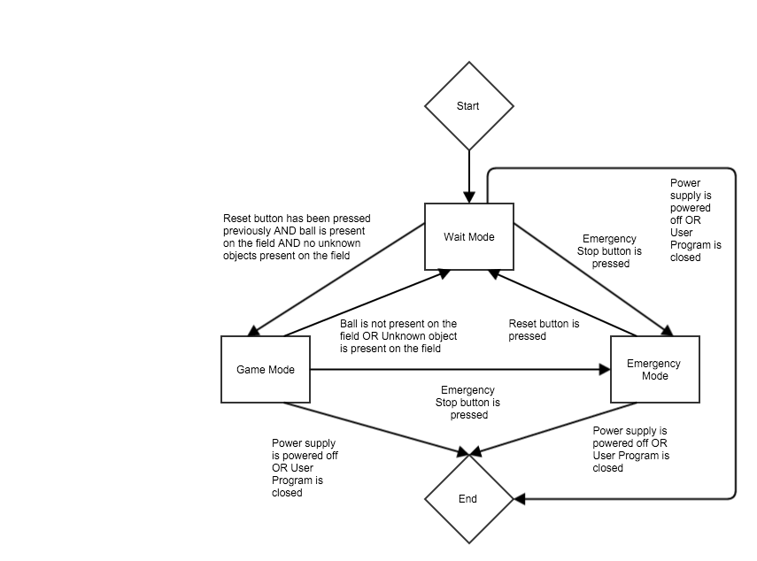

**Figure 6.** States transition diagram

## **7.4 System Shutdown:**

To shutdown the system, the following actions have to be done in the order that they are listed:

1. Power off the power supply
2. Exit user program

# **8 HARDWARE DESIGN**

## **8.1 Linear Motion**

The linear motion of the rod is achieved by using a “Belt Driven V-Slot Linear Actuator” (see Figure 7 below). Designed as an off-the-shelf solution to be used in 3D printers and CNC machines, its relatively low price, high accuracy and speed fit our needs perfectly.

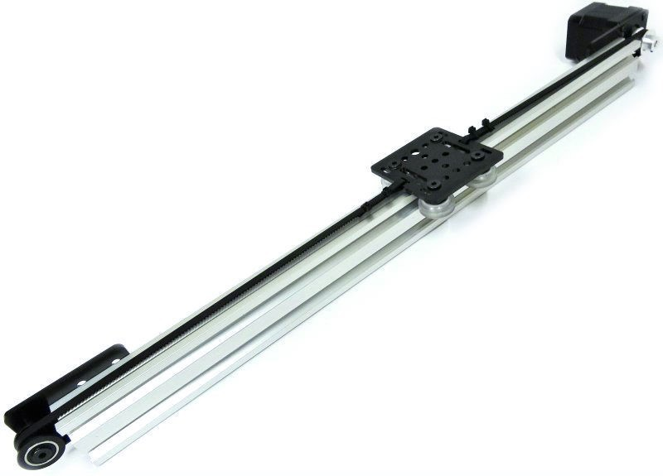

**Figure 7.**  Belt Driven V-Slot Linear Actuator

The v-slot gantry can slide freely on the v-slot rail. A stepper motor is used to control the position of the gantry using the GT2 Timing Belt and GT2 Timing Pulley. There will be a Micro Limit Switch installed on the rail to indicate a home position for the gantry.

Note that the servo motor that is used to control to rotational motion is mounted on the V-Slot Gantry by using a stepper motor mount (see Figure 33). The V-Slot Gantry can then move the servo motor linearly so that the linear motion and rotational motion of the foosmen can be achieved at the same time.

This subsystem contains these following major component:

|  |  |  |  |
| --- | --- | --- | --- |
| Name | Description | Quantity | Figure |
| V-Slot Rail | - Dimensions: 20mm x 40mm x 250mm | 1 | Figure 16 |
| V-Slot Gantry Set | - Mounted on 20mm wide V-Slot Rail | 1 | Figure 17 |
| Nema 17 Stepper Motor | - Shaft Size: 5mm  - Torque: 5.47 kg-cm  - Step Angle: 1.8  - DC 1.68 A/Phase | 1 | Figure 18 |
| GT2 Timing Belt | - Pitch: GT2 (2mm)  - Width: 5mm | 1 | Figure 19 |
| GT2 Timing Pulley | - Pitch: GT2 (2mm)  - 30 Tooth | 1 | Figure 20 |
| Micro Limit Switch (with mounting plate) | - Current: 0.5A  - Voltage: 125V/240V  - Dimensions: 20mm x 15 mm x 6mm | 1 | Figure 21 |

**Table 6.** Linear Motion Hardware

### **8.1.1 Relevant Calculations**

The linear movement of the rod is achieved by the combination of a stepper motor and a pulley system.

Since the maximum response time required is 300 ms (Requirements 6.3.2), a maximum of 100 ms can be allocated to the linear motion leaving 200 ms for other operations. In this amount of time, the rod should be able to finish the maximum linear movement allowed which is 962 mm.

Therefore, the rod should have an acceleration of:

$d_{x}=v_{0}t+\frac{1}{2}{a{}_{x}}^{}t{}^{2}⇒92mm=0+\frac{1}{2}{a{}_{x}}^{}(0.1sec){}^{2}$

$0.092 m=0.005a_{x}$

$a=18.4m/s{}^{2}$

Then:

$F_{x}=a_{x}(m_{rod}+m_{motor}+m_{plate})$

$F_{pulley}-f=18.4m/s{}^{2}(92.05g+17g+55g)$

$\frac{τ_{linear}}{r_{pulley}}-f=3.01852N$

Where the $τ_{linear}$ is the torque of the linear motor , $r_{pulley}$ is the radius of the timing pulley and $f$ is the total friction of the linear system.

The friction is estimated to be 0.3 N and the diameter of pulley is measured to be 17.625 mm.

Therefore maximum torque needed for the linear motor is:

$τ_{linear}=(3.01852N+0.3N)(0.017625m÷2)$

$=0.02924N∙m$

$=2.924N∙cm$

The Nema 17 stepper motor has a maximum torque of $5.47kg∙cm=5.366N∙cm$ which is more than we need.

## **8.2 Rotational Motion**

The rotational motion of the rod is achieved by using a Nema 16 Stepper Motor. This stepper motor is attached to the v-slot gantry with a Nema 17 Stepper motor mount (see Figure 33) and screws.

Due to the dimensions of the linear motion system, there will be a 50mm gap between the edge of the gantry and the end of foosman rod. Thus the rod will be replaced with a 5/16” x 2’ aluminum tube. The foosmen will then be re mounted on the new extended rod with screws. The stepper motor has a shaft with diameter of 5 mm. Then the motor coupling is used to connect servo motor shaft and the system controlled rods.

This subsystem has these hardware components:

|  |  |  |  |
| --- | --- | --- | --- |
| Name | Description | Quantity | Figure |
| Nema 16 Stepper Motor | - Shaft Size: 5mm  - Torque: 21 Ncm  - Step Angle: 1.8  - DC 1.68 A/Phase | 1 | Figure 23 |
| Nema 17 Stepper Motor Mount | - Can be used for Nema 17 and Nema 16 Stepper Motors | 1 | Figure 33 |
| Flexible Helical Coupling | - Dimensions: 24mm x 17mm x 19mm  - Holes: 5mm/8mm | 1 | Figure 24 |

Table 7. Rotational Motion and Power supply

## **8.3 Motor Controller**

We have chosen the Arduino Mega controller (Figure 25) for two reasons. The first one is the ease of development and testing on Arduino boards. The second is the availability of dedicated stepper motor shields for the arduino which will yield a better result for timing as the sending of signals is optimized. These shields also have in-built circuit protection and motor protection therefore preventing damage to the circuit or its components. The shield we will be using for this project is the RAMPS 1.4(Figure 26).

The RAMPS 1.4 motor shield is able to control 5 stepper motors at the same time using 5 A4988 motor drivers. We will be using the Ramps controller to control the two stepper motors used for linear motion and rotational motion. We will be using the X-axis, Y-axis, E-axis and Q-axis ports from the motors shield. The ports are labelled this way as they were originally meant for 3D printer use but can be used for controlling stepper motors in general. Originally we were going to use servos for linear motion but with the availability of linear systems for use with stepper motors and mechanical disadvantages of our previous mechanical designs, we have decided to use stepper motors for linear motion.

The distance-step mapping and angle-PWM mapping will be achieved by a Arduino Mega Board. The Arduino Mega board receives desired distance or angle from the user program through USB 2.0 interface and converts them into number of steps or PWM pulses.

The number of steps will be sent to A4988 Stepper Motor Drivers that are mounted on RAMPS 1.4 motor driver shield. With a 12V/30A external power supply the A4988 stepper motor drivers can drive the two Nema 17 motors effortlessly. The servo motors are also powered by the same power supply with a DC-DC voltage convertor. Full schematics are given next page in Figure 7.

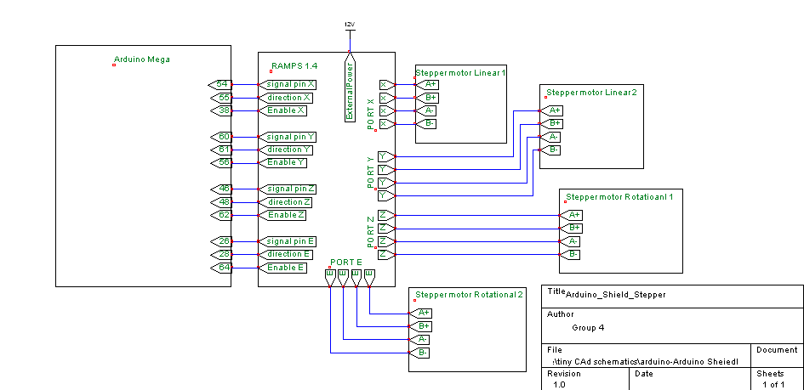

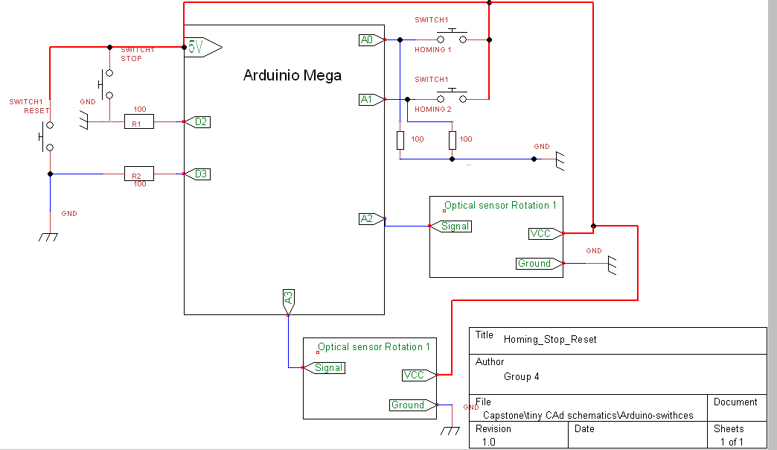

The motor controller uses these hardware components:

|  |  |  |  |
| --- | --- | --- | --- |
| Name | Description | Quantity | Figure |
| Arduino Mega | - Microcontroller: ATmega1280  - Operating Voltage: 5V  - Input Voltage  (recommended): 7-12V | 1 | Figure 25 |
| RAMPS 1.4 Stepper Motor Shield | - Drive up to 5 stepper motors  - Input Voltage  (recommended): 7-12V | 1 | Figure 26 |
| A4988 Stepper Motor Driver  (with heatsink) | - Simple step and direction control interface  - Short-to-ground and shorted-load protection  - Over-temperature thermal shutdown  - full-step, half-step, quarter-step, eighth-step, and sixteenth-step | 2 | Figure 27 |
| SUNSKY S-360-12  Power supply | - DC output voltage: 12V  - Rated output current: 30A  - DC output power: 348W | 1 | Figure 28 |
| LM2596  DC-DC converter | - Input: DC 3V to 40V  - Output: DC 1.5V to 35V | 1 | Figure 31 |
| BUZ73AH N-Mosfet | - max drain current of 5.5A | 1 | Figure 32 |

Table 8. Motor Controller

## **8.4 User Interface**

The hardware components of user interface consist a 2004 LCD Control Board and a pushbutton. The 2004 LCD Control Board contains a push button, an rotary encoder and a 20 Character x 4 Line LCD display. The LCD will be used to display system status and game score and it will be placed on the user side of the foosball table. The rotary encoder determines the response time of the system to achieve different difficulty levels. The push button that is mounted on the LCD Control Board functions as a reset button. The other push button which is the emergency button will be mounted on user side of the foosball table for ease of access.

Both of 2004 LCD Control Board and push button are controlled and powered by the Arduino Mega board. It also communicates with the user program that is running on PC through the USB 2.0 interface.

The 2004 LCD Control Board and Arduino Mega Board are connected as shown in Figure 10

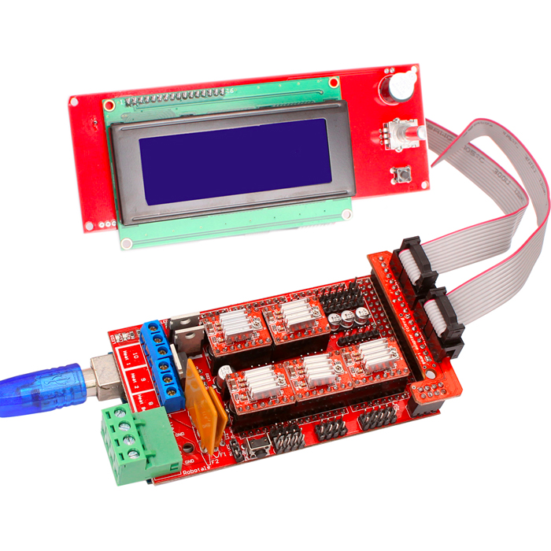

**Figure 10**. The 2004 LCD Control Board and Arduino Mega Board

The user interface system uses these hardware components:

|  |  |  |  |
| --- | --- | --- | --- |
| Name | Description | Quantity | Figure |
| 2004 LCD Control Board | - 4 lines of text, with 20 characters per line  - Integrated rotary encoder  - Integrated push button | 1 | Figure 28 |
| Mini Pushbutton Switch | - rated up to 50mA | 1 | Figure 29 |
| Resistor | - 1k ohm | 1 | N/A |

Table 9. User Interface

## **8.5 Computer Vision**

The vision of the system is achieved by using a PS3 Eye webcam due to its high performance and adaptability. In order to capture the entire foosball field by the camera, it needs to be raised to a certain height directly above the centre of the field. The camera stand is used to hold the camera at this height. After working with the image processing unit, the camera stand is set to be 510 mm high. The camera is screwed to the middle of the stand. The entire stand is screwed to the two sides of the foosball table.The setup is shown below in Figure 11.

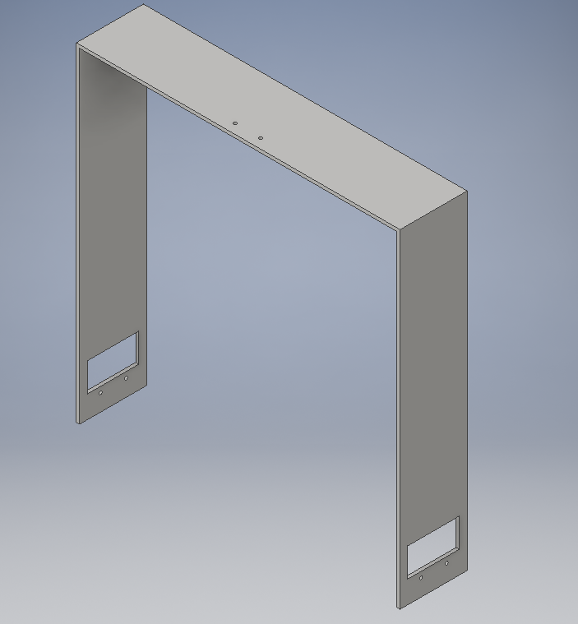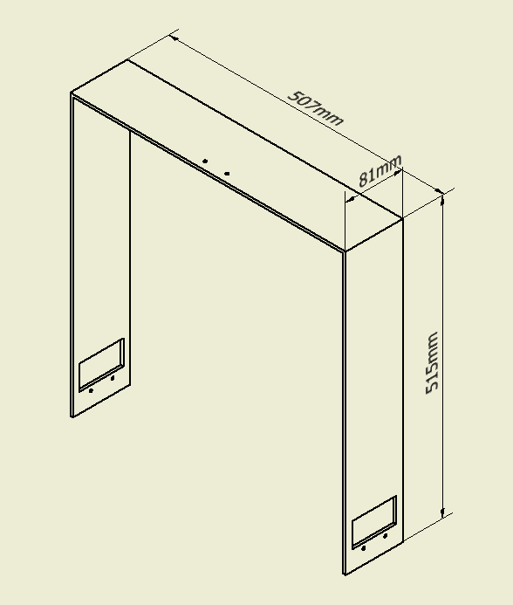

(A) (B)

**Figure 11**. Camera Stand(A) and Camera Stand Dimensions(B)

## **8.6 Hardware Cover**

### **8.6.1 Rod Protector**

The main purpose of this body feature is to keep the user unable to interfere with the rods controlled by the system. This will prevent the user from possible harm, as well as protecting the system from interference that can cause overloading of the motors.

The protector is designed as an acrylic cylinder that is 3mm in diameter and is 100mm in length to cover the entire path of the rods. The cylinder is hollow inside to allow movement of the rod. The rod is mounted onto a machined aluminum frame that is attached to the wooden base with screws.

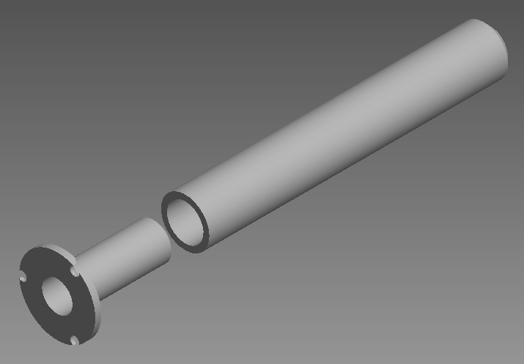

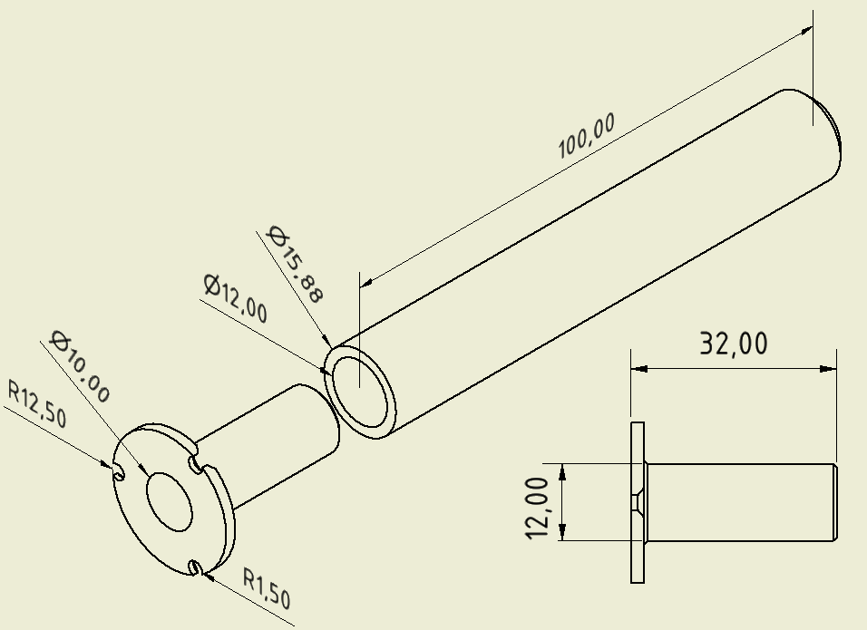

**Figure 12**. Rod Protector Dimension

### **8.6.2 Actuator Protector**

The main purpose of this body feature is to keep the user unable to interfere with the linear actuators controlled by the system. This will prevent the user from possible harm, as well as protecting the system from interference that can cause damaging of the hardware.

# **9 SOFTWARE DESIGN**

The software component is further divided into sub-modules according to their functionalities. This section describes the behaviour of each sub-module including their inputs, outputs , interface and timing constraints. Figure 13. below shows the hierarchy of the software program of the system.

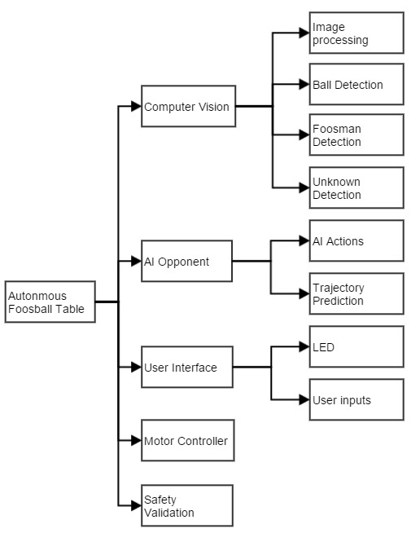

**Figure 13.** Modular Decomposition

## **9.1 Computer Vision**

Object detection and segmentation is the most important and challenging fundamental task of computer vision. Computer vision of this system is achieved by using OpenCV 3.0 and Python 2.7. We have selected PLAYSTATION Eye**™** camera to capture the image of the foosball field. This is a 0.3 Megapixel CMOS camera. It can achieve up to 75 fps at 640x480 pixels, or 120 fps at 320x240 pixels. It has 75 degrees field of view. We selected this particular camera as it is the cheapest camera which meets our system requirement 6.2.6, and has been tested.

**Use：**

cv2：Opecv 3.0 library

numpy: NumPy is the fundamental package for scientific computing with Python.

State Variable:

Boolean cam_setup: Cam_setup is true if camera is correctly initialled.

### **9.1.1 Image Processing:**

|  |  |
| --- | --- |
| *Behaviour:* | Image processing sets up webcam in the initial state, reads camera image and converts the image to hsv color mode image. HSV image will be finally used for detecting foosball, foosman position and detection of unknown object |
| *Input:* | None |
| *Output:* | numpy.array hsv_field: hsv field image  numpy.array hsv_edge_1: hsv image of edge 1  numpy.array hsv_edge_2: hsv image of edge 2  numpy.array hsv_edge_3: hsv image of edge 3  numpy.array hsv_edge_4: hsv image of edge 4  boolean cam_setup |
| *Constant:* | k_cam_width  k_cam_height  k_edge_x_min  k_edge_x_max  k_edge_y_min  k_edge_y_max |
| *Internal:* | VideoCapture _cap: VideoCapture object  numpy.array _cam_image: image output from camera |
| *Interface:* | setupCam() → cam_setup  getHSV() → hsv_field, hsv_edge_2, hsv_edge_3, hsv_edge_4 |
| *Assumption:* | Camera is connected to the computer.  Camera outputs correct images. |
| *Exception:* | call getHSV() function before called setupCam() function |
| *Secret* | camera interface  image processing algorithms  computer vision library  field and edges locations in the camera captured image |
| *Timing Constraints:* | The processing time for setting up the should be less than 5 s. The processing time for getHSV(<VideoCapture object>) function should be less than 14 ms. The PLAYSTATION Eye**™** camera is be able to run max 120 fps with resolution of 320X240, the processing time will be constraint by resolution and frame per second. We set frame speed as 90 fps with 320X240 resolution, such setting satisfies requirements 8.2.1 and 8.2.6. |

**Functions**

|  |  |
| --- | --- |
| Name | setupCam() |
| Type | accessor |
| Purpose | setup the camera in the initial state |
| Detail | This function sets up the camera and returns true if camera initials correctly. |
| Input | None |
| Output | boolean cam_setup |
| exception | camera does not set up within 5s |
| Dependencies | Camera need to connect to the computer |

|  |  |
| --- | --- |
| Name | getHSV() |
| Type | accessor |
| Purpose | Getting hsv image from camera |
| Detail | This function reads image input from camera, converts hsv image and returns the hsv image. |
| Input | None |
| Output | numpy.array hsv_field  numpy.array hsv_edge_1  numpy.array hsv_edge_2  numpy.array hsv_edge_3  numpy.array hsv_edge_4 |
| Dependencies | Camera needs to be connected to the computer and setupCam() function works correctly |

### **9.1.2** **Ball Detection:**

|  |  |
| --- | --- |
| *Behaviour:* | Ball Detection finds the ball position by computer vision. The foosball would be detected by color and size.This function will return three values which represent x position, y position of center of the ball and a boolean for checking if there is a ball detected. |
| *Input:* | numpy.array hsv_field |
| *Output:* | float m_ball_x  float m_ball_y  boolean m_ball_found |
| *Constant:* | k_cam_width  k_cam_height  k_ball_diameter |
| *Internal:* | numpy.array _ball_lower_color: ball lower hsv color limit  numpy.array _ball_upper_color: ball upper hsv color limit |
| *Interface:* | getBallPosition(hsv_field)→ m_ball_x, m_ball_y, m_ball_found  detect ball position and return the actual foosball position in millimeter. |
| *Assumption:* | Image processing module works correctly.  Only one ball shows up on the foosball field.  Ball color range measured correctly. |
| *Secret* | ball detection algorithms  ball color |
| *Timing Constraints:* | The processing time shall less than 2 ms.  The processing time of ball detection will be limited by the opencv findContours and minEnclosingCircle functions. |

**Functions**

|  |  |
| --- | --- |
| Name | getBallPosition() |
| Type | accessor |
| Purpose | Tracking ball position |
| Detail | This function returns ball’s physical linear and angular positions. This function also returns if the ball shows in the field. |
| Input | numpy.array hsv_field |
| Output | float m_ball_x,  float m_ball_y,  boolean m_ball_found |
| Exception | If the ball does not shows in the field, the function returns -1,-1,false. |
| Dependencies | GetHSV() function works correctly. GetHSV() function called before this function. |

### **9.1.3 Foosman Detection:**

|  |  |
| --- | --- |
| *Behaviour:* | Foosman detection will be used for home position checking and correct linear or angular positions.Foosman detection finds the linear and angular position of foosman through computer vision. Foosman would be detected by color and center position. This module will return linear position and angular positions of the center foosman of each row. |
| *Input:* | numpy.array hsv_field |
| *Output:* | float m_row1_lp  float m_row2_lp  float m_enemy1_lp  float m_enemy2_lp  float m_row1_ap  float m_row2_ap  float m_enemy1_ap  float m_enemy2_ap |
| *Constant:* | k_cam_width  k_cam_height  k_edge_x_min  k_edge_x_max  k_edge_y_min  k_edge_y_max |
| *Internal:* | numpy.array _row_lower_color: row lower hsv color limit  numpy.array _row_upper_color: row upper hsv color limit  numpy.array _enermy_lower_color: enemy lower hsv color limit  numpy.array _enermy_upper_color: enemy upper hsv color limit |
| *Interface:* | getRowPosition(hsv_field) → m_row1_lp, m_row2_lp,m_row1_ap, m_row2_ap  getEnermyPosition(hsv_field) → m_enemy1_lp, m_enemy2_lp, m_enemy1_ap, m_enemy2_ap |
| *Assumption：* | Image processing module works correctly.  Robot’s and user’s foosmen color limitation measured correctly. |
| *Secret* | foosmen detection algorithm  foosmen color |
| *Timing Constraints:* | The processing time for getRowPosition() or getEnermyPosition() function shall take less than 5 ms.  The processing time for foosman detection is constrained by opencv2 findContours and boundingRect functions. |

Functions:

|  |  |
| --- | --- |
| Name | getRowPosition() |
| Type | accessor |
| Purpose | Tracking robot’s foosmen positions |
| Detail | The function returns row’s physical linear and angular positions. |
| Input | numpy.array hsv_field |
| Output | float m_row1_lp,  float m_row2_lp  float m_row1_ap,  float m_row2_ap |
| Exception | The function returns 0,0,0,0 if less than 3 foosmen detected in any row. |
| Dependencies | GetHSV() function works correctly. GetHSV() function called before this function. |

|  |  |
| --- | --- |
| Name | getEnermyPosition() |
| Type | accessor |
| Purpose | Tracking user's foosmen positions |
| Detail | The function returns enemy's physical linear and angular positions. |
| Input | numpy.array hsv_field |
| Output | float m_enemy1_lp, float m_enemy2_lp,float m_enemy1_ap, float m_enemy2_ap |
| Exception | The function returns 0,0,0,0 if less than 3 foosmen detected in any row. |
| Dependencies | GetHSV() function works correctly. GetHSV() function is called before this function. |

### **9.1.4 Unknown Detection:**

|  |  |
| --- | --- |
| *Behaviour:* | Unknown detection checks if unknown objects show up on top of the side panels and end panels. We choose a special color for the top of the panels and check if any objects block the panels. |
| *Input:* | numpy.array hsv_edge_x1  numpy.array hsv_edge_x2  numpy.array hsv_edge_y1  numpy.array hsv_edge_y2 |
| *Output:* | boolean m_unknown_object |
| *Constant:* | k_edge_x_min  k_edge_x_max  k_edge_y_min  k_edge_y_max |
| *Internal:* | numpy.array _edge_lower_color: edge lower hsv color limit  numpy.array _edge_upper_color: edge upper hsv color limit |
| *Interface:* | getUnknown(hsv_edge_x1, hsv_edge_x2, hsv_edge_y1, hsv_edge_y2) → m_unknown_object |
| *Assumption:* | Image processing module works correctly.  Panel color range measured correctly.  The color of known object is not in Panel color range. |
| *Secret* | unknown detection algorithm  panel color |
| *Timing Constraints:* | The processing time shall be less than 5 ms.  The processing time for foosman detection is constrained by opencv2 findContours and boundingRect. |

Functions:

|  |  |
| --- | --- |
| Name | getUnknown() |
| Type | accessor |
| Purpose | Check if unknown objects block the panels . Will be used as a safety measure. |
| Detail | The function returns true if unknown objects appear in the field. |
| Input | numpy.array hsv_edge_x1,  numpy.array hsv_edge_x2,  numpy.array hsv_edge_y1,  numpy.array hsv_edge_y2 |
| Output | boolean m_unknown_object |
| Exception | The function returns 0,0,0,0 if less than 3 foosmen detected in any row. |
| Dependencies | GetHSV() function works correctly. GetHSV() function called before this function.j |

### **9.1.5 Goal Detection:**

|  |  |
| --- | --- |
| *Behaviour:* | Goal detection is an algorithm that detects goal. This function will inspect both user and robotic side goal.A boolean value will be returned. |
| *Input:* | numpy.array hsv_field |
| *Output:* | boolean m_goal_user  boolean m_goal_robot |
| *Constant:* | k_edge_x_min  k_edge_x_max  k_edge_y_min  k_edge_y_max  k_goal_width  k_goal_length |
| *Internal:* | numpy.array _goal_lower_color: ball lower hsv color limit  numpy.array _goal_upper_color: ball upper hsv color limit |
| *Interface:* | getGoal(hsv_field) → m_goal_user, m_goal_robot |
| *Assumption* | Image processing module works correctly.  User takes ball out of the goal before the next game starts. |
| *Exception:* | More than one ball detected in goal area. |
| *Secret* | goal detection algorithm |
| *Timing Constraints:* | The processing time shall be less than 3 ms.  The processing time of ball detection will be limited by the opencv2 findContours and minEnclosingCircle functions. |

Functions:

|  |  |
| --- | --- |
| Name | getGoal() |
| Type | accessor |
| Purpose | Detecting goal |
| Detail | This function will return two booleans. If user gets goal, then the return value will be true. |
| Input | numpy.array hsv_field |
| Output | boolean m_goal_user,  boolean m_goal_robot |
| Exception | The function returns True when more than one ball is detected in the goal. |
| Dependencies | getHSV() function works correctly. |

## **9.2 AI Opponent**

The AI opponent part of the system has two main responsibilities:to predict the foosball trajectory and to give AI actions. To predict foosball's future position we will use previous positions to estimate its current velocity. AI’s Actions are implemented such that each row will be treated as one AI entity and they can send broadcast messages to each other. Detailed class diagram are shown below in Figure 14.

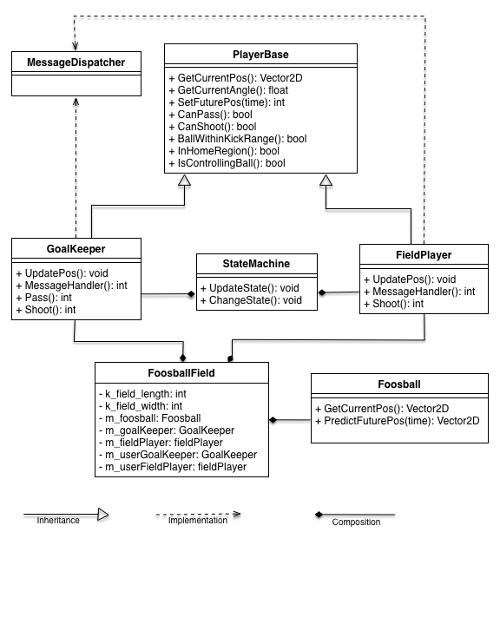

**Figure 14.** AI Class Diagram

AI actions are determined by “Greedy Algorithm” as it is simple to implement for the initial version of the system. The algorithm could be implemented as follows:

1. Acquire ball position and heading direction
2. Locate nearest controlled foosman to projected location
3. Calculate the distance needed to move the foosman into the path of the ball, kicking if possible.
4. Output calculated move for the Motor Controller of appropriate rod
5. Repeat constantly based on updated system state

### **9.2.1 Trajectory Prediction:**

|  |  |
| --- | --- |
| *Behaviour:* | Trajectory Prediction is used to predict ball path base on previous and current frame motion detection. This information will eventually be sent to the AI strategy module. |
| *Input:* | float m_ball_x  float m_ball_y  boolean m_ball_found |
| *Output:* | array in_ball_path  float in_ball_speed |
| *Internal:* | point _ball_pre : store previse ball position, initial as (-1,-1)  array _ball_path: store trajectory, initial as empty array  float _ball_speed: ball speed, initial as 0 |
| *Interface:* | getBallSpeed() → in_ball_speed  getTrajectory() → in_ball_path  predictTrajectory(m_ball_x, m_ball_y, m_ball_found) → None |
| *Secret* | ball position prediction algorithm,  trajectory prediction algorithm,  ball speed prediction algorithm |
| *Timing Constraints:* | The processing time of Trajectory prediction is determined by the speed of the ball, the faster the speed, the more predictions that need to be done. The processing time shall be under 50ms in all cases. |

Functions:

|  |  |
| --- | --- |
| Name | getBallSpeed() |
| Type | accessor |
| Purpose | Tacking ball speed |
| Detail | This function will return a float value which represents foosball speed |
| Input | None |
| Output | float in_ball_speed |
| Exception | Function return 0 if the ball path is not predictable. |
| Dependencies | predictTrajectory(m_ball_x, m_ball_y, m_ball_found)has to be called before this function |

|  |  |
| --- | --- |
| Name | getTrajectory() |
| Type | accessor |
| Purpose | Predicting ball trajectory |
| Detail | This function will return an array of points which represent predicted ball trajectory |
| Input | None |
| Output | array in_ball_path |
| Dependencies | predictTrajectory(m_ball_x, m_ball_y, m_ball_found)has to be called before this function |

|  |  |
| --- | --- |
| Name | predictTrajectory() |
| Type | mutator |
| Detail | This function will detect ball speed and predict ball trajectory for future, the algorithm is calculating difference between current and past ball position to predict future ball path |
| Input | float m_ball_x, float m_ball_y, boolean m_ball_found |
| Output | None |
| Dependencies | findBallPosition(numpy.array hsv_field) called before this function. |

### **9.2.2 AI Actions:**

|  |  |
| --- | --- |
| *Behaviour:* | This module determines the AI actions according to the current ball position, robot foosman position and user foosman position. Then output the robot foosman’s future linear and angular position. |
| *Input:* | float m_row1_lp  float m_row2_lp  float m_row1_ap  float m_row2_ap  float in_ball_speed |
| *Output:* | int foosmen  float out_row1_lp  float out_row2_lp |
| *Internal:* | float _ball_speed: ball speed, initial as 0  int foosman |
| *Interface:* | getNearestFoosman() → foosman  getDistanceToMove() → out_row1_lp, out_row2_lp  kick() |
| *Secret:* | method to get nearest foosman,  method to calculate distance to move, |

|  |  |
| --- | --- |
| Name | getNearestFoosman() |
| Type | accessor |
| Purpose | Find the nearest foosman |
| Detail | This function finds the nearest foosman to the ball by comparing the magnitude of the distance vectors |
| Input | float m_row1_lp  float m_row2_lp  float in_ball_speed |
| Output | int foosman |
| Dependencies | predictTrajectory(m_ball_x, m_ball_y, m_ball_found)has to be called before this function |

|  |  |
| --- | --- |
| Name | getDistanceToMove() |
| Type | accessor |
| Purpose | Predicting ball trajectory |
| Detail | This function will return an array of points which represent predicted ball trajectory |
| Input | None |
| Output | float out_row1_lp,  float out_row2_lp |
| Dependencies | getNearestFoosman() |

|  |  |
| --- | --- |
| Name | kick() |
| Type | accessor |
| Purpose | Predicting ball trajectory |
| Detail | This function will return an array of points which represent predicted ball trajectory |
| Input | int foosman |
| Output | float m_row1_ap  foat m_row2_ap |
| Dependencies | None |

## **9.3 User Interface**

The user interface consists hardware user interface and software user interface.

* Hardware: pushbuttons for emergency stop function and reset function
* Software: difficulty selection buttons and prompt messages for display the current system state.

### **9.3.1 LCD Display:**

|  |  |
| --- | --- |
| *Behaviour:* | User can get feedback information from system through a LCD display that is mounted on the user side of the table. |
| *Input:* | int c_mode  int in_difficulty_level  boolean c_gameplay |
| *Output:* | String out_message |
| *Constant:* | String ERROR_MESSAGE |
| *Internal:* | String _message: initial as ‘Welcome’ |
| *Interface:* | setMessage(boolean c_gameplay, int c_mode, int in_difficulty_level) → out_message  getMessage() → out_message |
| *Assumption:* | LCD is connected to the controller board before system initialization |
| *Exception:* | When c_mode input is not equal to 0,1 or 2, LCD displays ERROR_MESSAGE.  in_dificulty_level not equal to 0,1 or 2. LED displays ERROR_MESSAGE |
| *Secret* | LCD interface  LCD display message |
| *Timing Constraints:* | The processing time of this module shall be less than 5ms. The human-machine interaction time is limited by the communication speed between LCD and microcontroller board and the update rate of Arduino board. |

Functions:

|  |  |
| --- | --- |
| Name | setMessage() |
| State | mutator |
| Detail | This function will set LCD display message and prove system feedback information on LCD display. |
| Input | boolean c_gameplay, int c_mode, int in_difficulty_level |
| Output | string out_message |
| Dependencies | None |

|  |  |
| --- | --- |
| Name | getMessage() |
| State | accessor |
| Detail | This function return the message display on the LCD. |
| Input | None |
| Output | string out_message |
| Dependencies | None |

### **9.3.2 User inputs:**

|  |  |
| --- | --- |
| *Behaviour:* | This module is for the user to interact with the system including reset, difficulty selection and emergency stop functions. This module implements in microcontroller. |
| *Input:* | digital m_reset  digital m_safety  analog m_difficulty_select |
| *Output:* | boolean in_rest  boolean in_safety  int in_difficulty_select |
| *Initial：* | None |
| *Constant:* | None |
| *Interface:* | Integer getDifficultyLevel()  void getRest()  void getSafety() |
| *Secret* | input hardware |
| *Timing Constraints:* | The processing time of this module shall be less than 5ms. The human-machine interaction time is limited by the communication speed between microcontroller and PC |

|  |  |
| --- | --- |
| Name | getRest() |
| Type | accessor |
| Purpose | Getting user reset input |
| Explanation | This function will read the digital reset input and convert to the software reset input. |
| Input | digital m_reset |
| Output | Boolean in_rest |
| Dependencies | None |

|  |  |
| --- | --- |
| Name | getSafety() |
| Type | accessor |
| Purpose | Getting user safety input |
| Detail | This function will read the digital safety input and convert to the software safety input. |
| Input | digital m_safety |
| Output | Boolean in_safety |
| Dependencies | None |

|  |  |
| --- | --- |
| Name | getDifficulty() |
| Type | accessor |
| Purpose | Getting user input |
| Detail | This function will read the analog difficulty input and convert to the software difficulty input. |
| Input | analog m_difficulty_select |
| Output | Int m_difficulty_select |
| Dependencies | None |

## **9.4 Safety Validation**

Safety validation module ensures safety. Safety validation is done on both hardware and software, both can trigger the system into emergency mode or wait mode. The hardware part has a listener on the emergency stop button to make sure the system can be manually stopped by the user. The software part uses computer vision to detect unknown objects on the foosball field.

**Safety Validation:**

|  |  |
| --- | --- |
| *Behaviour:* | This module is responsible for ensuring safety, it takes push button signal from microcontroller, ball detection and unknown object detection from computer vision and determines system mode |
| *Input:* | m_unknown_object  m_ball_found  m_safety |
| *Output:* | c_mode |
| *Internal:* | Boolean isSafe |
| *Interface:* | setSafetyStatus(Boolean m_safety,Boolean m_ball_found, Boolean m_unknown_object)  getSafetyStatus(): Integer |
| *Secret* | mode setting  method of safety validation |
| *Timing Constraints:* | Although the decision making time is limited by the processing time for the unknown object detection. The entire safety validation process should be limited under 30ms. |

|  |  |
| --- | --- |
| Name | setSafetyStatus() |
| Type | mutator |
| Purpose | Change the status of safety |
| Detail | isSafe = ¬m_safety⋁¬m_ball_found⋁m_unknown_object |
| Input | Boolean m_safety  Boolean m_ball_found  Boolean m_unknown_object |
| Output | Int return_code |
| Dependencies | None |

|  |  |
| --- | --- |
| Name | getSafetyStatus() |
| Type | accessor |
| Purpose | Tracking safety status |
| Detail | return isSafe |
| Input | None |
| Output | Boolean isSafe |
| Dependencies | None |

## **9.5 Motor Controller**

The motor controller has a functions it must carry out. These include:

* Sending Signals to the stepper motors
* Communication to the PC and converting data to that understood by the motors
* Displaying System Status to the user
* Providing safety measures through halting of the system
* Synchronisation of motors for reducing build up of error

### **9.5.1 MIS(Module interface Specification)**

All the functions will be divided into modules as they will provide abstraction and ease of programming.Below is a list of all the modules and their descriptions

|  |  |  |
| --- | --- | --- |
| Modules | Methods | Description |
| Motor Control | Move_Motors()  Distance_to_NeededSteps()  Angle_to_NeededSteps()  Home_Motors() | The methods for controlling the motors will be placed here. Any conversion function will be placed here as well |
| PC communication | PC_Com() | Methods required for PC communication |
| Initialization | Stepper_Pin_Config()  Serial_Config()  Homing_Config()  STOP_RESET_Config()  STOP_Interrupt_Config() | Initialize pins for motor,reset and stop switches and homing switches |
| Safety | Stop_Interrupt_Handler() | Methods and interrupts to implement safety functions for the system |

### **9.5.2 Motor Control:**

|  |  |
| --- | --- |
| *Behaviour:* | This module will contain all the functions that will help the stepper or servo motor move to its intended position. This module will make use of the provided Arduino.h ,Servo.h and the inbuilt math libraries for development. It must be noted that to move the stepper motors by one step , a voltage pin must be raised HIGH and the set to LOW to create this step . The motor shield and drivers takes care of the rest. |

|  |  |
| --- | --- |
| Name | Move_Motors() |
| Type | modifier |
| Purpose | Moves the linear and rotational stepper motors to their correct position in parallel |
| Input | int Motor_number  float distance  int *Current_Steps_Position[Motor_Number] |
| Output | 1 - Succes  0 - Fail (distance not in range or wrong motor number) |
| Dependencies | Distance_to_NeededSteps() |

|  |  |
| --- | --- |
| Name | Distance_to_NeededSteps() |
| Type | - |
| Purpose | Convert the linear distance from PC to number of steps to be moved by the particular stepper motor |
| Input | float* length_angles  int *Current_Steps_Position[Motor_Number] |
| Output | int Steps_to_move |
| Dependencies | none |

|  |  |
| --- | --- |
| Name | Angle_to_NeededSteps() |
| Type | - |
| Purpose | Convert the angle from PC to number of steps to be moved by the particular stepper motor |
| Input | float* length_angles  int *Current_Steps_Position[Motor_Number] |
| Output | int Steps_to_move |

|  |  |
| --- | --- |
| Name | Home_Motors() |
| Type | - |
| Purpose | The linear motors are homed when they encounter the homing switch. When the linear stepper motors encounter this event,the current step position is given a value of 0. The rotational motors are homed by sensing the value of the optical sensor. |
| Input | int *Current_Steps_Position |
| Output | 1 - Succes  0 - Fail(homing switch not encountered in expected time) |
| Dependencies | - |

### **9.5.3 PC Communication:**

|  |  |
| --- | --- |
| *Behaviour:* | This module has methods solely for communicating with the PC as our current design is heavily reliant on the PC. These same methods can be used if image processing and AI were moved to a controller in the future. |

|  |  |
| --- | --- |
| Name | PC_Com() |
| Type | - |
| Purpose | This receives the necessary data and sends a confirmation signal to ensure that the data has been received. |
| Input | char* data_array |
| Output | None |
| Dependencies | - |

### **9.5.4 Initialization:**

|  |  |
| --- | --- |
| Behaviour: | For the arduino certain commands can only be run in the main .ino file. These include the initialization of pins for stepper motors, switches and serial communication. This module will be placed in the main .ino file |

|  |  |
| --- | --- |
| Name | Stepper_Pin_Config() |
| Type | - |
| Purpose | Configures the stepper motor pins. Sets the direction and enables the |
| Input | None |
| Output | None |
| Dependencies | - |

|  |  |
| --- | --- |
| Name | Serial_Config() |
| Type | - |
| Purpose | Configures Serial communication and activates it at the specified baudrate |
| Input | int Baudrate |
| Output | None |
| Dependencies | - |

|  |  |
| --- | --- |
| Name | Homing_Config() |
| Type | - |
| Purpose | Configures Homing switches |
| Input | None |
| Output | None |

|  |  |
| --- | --- |
| Name | STOP_RESET_Config() |
| Type | - |
| Purpose | Configures STOP and RESET pins |
| Input | int STOP_Pin  int RESET_Pin |
| Output | None |
| Dependencies | - |

|  |  |
| --- | --- |
| Name | STOP_Interrupt_Config() |
| Type | - |
| Purpose | Configures the STOP interrupt |
| Input | int STOP_Pin |
| Output | None |
| Dependencies | - |

### **9.5.5 MID - Module Interface Design**

For the Arduino different modules will require specific pin numbers and specific constants. It is much simpler if for general descriptions there is one header file which has all relevant information made use by all the modules.

*Variables available to all modules (any variable declared in the main arduino file is automatically available to all)*

|  |  |  |
| --- | --- | --- |
| Variable Name | Type | Description or values |
| Distances_Angles[4] | INT* | This will store the actual distances and angles to be moved to received from serial communication.  0 - length row 1  1 - angle row 1  2 - length row 2  3 - angle 2 |
| k_max_linear_range | INT | Max distance linear rod can Obtained from the defined constants Section 6.2 |
| k_max_angular_range | FLOAT | Max angular distance possible. Obtained from the defined constants Section 6.2 |
| Defaul_Rotational_Angle | FLOAT | Default Value the rotational motors should go to. It is at 90 degrees but can be changed. |
| X stepper is for row 1  Step_Pin_X  Step_Dir_X  Y stepper is for row 2  Step_Pin_Y  Step_Dir_Y | INT | The pins on the arduino that will be used to control the stepper motors  Refer to circuit schematic for pin numbers. |
| Z stepper is for row 1 rotational  Step_Pin_Z  Step_Dir_Z |
| E stepper is for row 2 rotational  Step_Pin_E  Step_Dir_E |
| motor_current[4] | INT* | An array that records the current step position of the motors.  0 - linear motor 1  1 - rotational motor 1  2 - linear motor 2  3 - for rotational motor 2 |
| Homing_Pin_M1  Homing_Pin_M2  Optical_Pin_M3  Optical_Pin_M4 | INT | Pins that will be used to read the state of the homing switches  Pin_M1 - pin A0  Pin_M2 - pin A1  Pin_M3 - pin A2  Pin_M4 - pin A3 |
| sensor_pins[4] | INT* | Array that hold all sensor pins . This would be so code will not have to be changed deeply if pins are.  0 - Sensor pin for linear motor 1  1 - Sensor pin for rotational motor 1  2- Sensor pin for linear motor 2  3 - Sensor pin for rotational motor 2 |
| STOP_Pin  RESET_Pin | INT | Pins |
| Baudrate | INT | Baud rate value for serial communication. For this design we will try to use the highest possible baud rate achievable between the PC and the Arduino |
| c_mode | INT | The mode of the system. Critical when system switches to stop mode |

### **9.5.6 Module Name - Motor Control**

*Description:*

This module will contain all the functions that will help the stepper or servo motor move to its intended position. This module will make use of the provided Arduino.h and Servo.h libraries for development.

#### **9.5.6.1 Move_Motor**

Internal Variables : int Steps_to_move[4] , int direction[4],int step_pins[4]

NOTE : This function makes use of the function Distance_to_NeededSteps() and Angle_to_NeededSteps() for carrying out its purpose. It moves all four motors at the same time.

* float Steps_to_move[0,2] = Distance_to_NeededSteps (distance_angles[0,2], motor_current [0,2])
* float Steps_to_move[1,3] = Angle_to_NeededSteps (distance_angles[1,3], motor_current [1,3])
* if(Steps_to_move[i]<0)
  + change direction of motor i to counterclockwise
  + direction[i] = -1
* else
  + change direction of motor to clockwise
  + direction[i] = 1
* find the maximum number of steps to be moved among all the motors
* for(i=0 to max steps)
  + for (y=0 to 4)
    - if( steps to move[y]>i)
      * turn step_pin[y] HIGH
  + enforce necessary delays for step pin to turn
  + for(y-0 to 4)
    - if( steps to move[y]>i)
      * turn step_pin[y] LOW
      * motor_current[y] = motor_current[y] + direction
* return(1) //successful

#### **9.5.6.2 Distance_to_NeededSteps**

Variables required - Spacing_teeth, Num_teeth,linear_steps, linear_length[i] , motor_current[i]

* length_per_steps = (spacing_teeth * num_teeth) / linear_steps;
* steps_needed = linear_length/length_per_steps - motor_current;

#### **9.5.6.3 Angle_to_NeededSteps**

Variables required -steps_per_revolution,motor_current[i]

* steps_needed = (angle * steps_per_revolution) / (360) - motor_current
* return(steps_needed)

#### **9.5.6.4 Home_Motors**

Variables Required - sensor_pins[4], Motor_direction_pins[4], Motor_Step_pins[4], Max_steps

Note Max _steps is the longest number of steps the motors would have to turn before they reach home and it is from calculations show to be 300. FOr homing Max_steps will be set to 400 just for assurance.

* Change all the directions of all the motors to anti clockwise
* for(i in 0 to Max_steps)
  + for (y=0;y<4;y++)
    - check sensor_pins[y] value
    - if value determines that motor has not reached homing state
      * Set Motor_Step_pin[y] HIGH
    - Delay to give motor enough time to complete the step
    - check sensor_pins[y] value again
    - if value determines that motor has not reached homing state
      * Set Motor_Step_pin[y] LOW

### **9.5.7 Module Name : PC Communication**

Description : this module has methods solely for communicating with the PC as our current design is heavily reliant on the PC. This same method can be used if image processing and AI were moved to a controller in the future.

#### **9.5.7.1 PC_Receive**

NOTE : Receiving data from PC is very specialised with 5 pieces of information which are row 1 linear steps, row 1 rotational steps ,row 2 linear steps,row 2 rotational steps and a safety flag. This will be sent as one long comma delimited string to minimize time delays and will be broken down by the arduino and filled into different arrays .Therefore it must be ensured that data is received .

* Receive all the data
* Break down into separate components and fill the distance_angles array.

### **9.5.8 Module name : Initialization**

Description : For the arduino certain commands can only be run in the main .ino file. These include the initialization of pins for stepper motors, switches and serial communication. This module will be placed in the main .ino file

#### **9.5.8.1 Stepper_Pin_Config()**

* Configure Stepper motor pins to Output state and enables them

#### **9.5.8.2 Serial_Config()**

* Configure the Serial communication with the provided int Baudrate

#### **9.5.8.3 Homing_Config()**

* Configure the homing switches pins to Input mode

#### **9.5.8.4 STOP_RESET_Config()**

* Configure The STOP and reset pins to input mode

# **10 SCHEDULING**

Time is a critical factor in this project. Proper synchronization of tasks are necessary along with fast execution times to minimize delays and ensure that the system will meet its requirements. The image processing as well as AI control is being done on the PC due to the high processing power available on these devices. We were able to obtain 50 FPS from image processing which is the biggest bottleneck on the PC side of timing. The AI commands are non-expensive as they will run on an extremely quick processor therefore are insignificant to the time delays. Thelast responsibility of the PC is to communicate with Arduino which leads to considerable delays as the Arduino must be prepared to accept commands before it can start communicating.

On the arduino tasks will use periodic scheduling.We will have 3 main periodic tasks

* Move_Steps (move stepper motors)
* Move_Servo (move servo motors)
* PC_Communication (Check if PC is sending any data)

The safety feature make use of interrupts and are not included in periodic checking.

For moving stepper motors we are using a shield which accepts commands in the form of steps which it executes independent of the Arduino therefore does not cause any significant delays. The servo motors have to be moved as well and are managed using the inbuilt servo library. The functions are designed in a way that they won't affect timing adversely therefore delays are kept to a minimum through motor control. For communicating with the PC ,the Arduino will check the serial lines every 20 ms.The PC timeout for Serial Communication is 500ms therefore 20ms is a safe period for checking communication. Any less than that would be useless as the motors will take time to move to their previous destinations which cannot be interrupted. Move_Steps and Move_Servo will be executed every 100ms. This will give it enough time to move to its previously defined destination .

# **11 UNDESIRED EVENT HANDLING**

|  |  |  |
| --- | --- | --- |
| **Case** | **Possible situation** | **Solution** |
| Foosball not moving in foosman reachable area | Electrical components failure  Mechanical parts are stuck  Ball is stuck | The system will detect the event and stop all the actuators and goes to emergency mode. User will be notified by an error message when a fault occurs. |
| Foosball not moving in user reachable area | ball is stuck  user is away | The system will stay in gameplay mode. |
| Ball jumps over the foosmen | strong shot from user  strong shot from robot | The system will go to wait mode |
| Ball not found on table | jump over table border  ball is under foosman or rod | The system will go to wait mode |
| Linear/Angular actuator not working | user pulling or pushing the system controlled rods  electrical components fail  ball is stuck | If the the actuator does not work, the system will automatically go to stop mode and a signal will notify the user that a fault has occurred. |

Table 10. Undesired Event Handling

# **12 NORMAL OPERATION**

|  |  |
| --- | --- |
| **Normal Use Cases** | **Description** |
| Game is requested | The game is manually enabled by the user, either to start a new game or resume after a goal is scored. The system will first go to waiting mode and wait for the foosball to show in the field before initiating normal game behavior. |
| Goal is scored | Each time the ball entering the goal is counted as a point. After a goal is scored, the system goes to waiting mode and waits for the user to retrieve the ball and put it in the field. The score has to be incremented manually by the user. |
| Game is finished | The system will detect completion of the game, move the foosmen to the default position and goes to waiting mode. |
| Difficult level setting | The system has three difficulty levels (“easy”,”normal”,”advanced”) and the default difficulty level setting is “normal”. User can change the difficult level of the system when the system is in waiting mode. |
| Emergency stop | The system goes to emergency mode when unknown objects are present in the football field. Once in this mode, all the mechanical motions must stop within 500ms. |
| Defence strategy | The system will recognize foosball position and speed, robotic foosman will block ball according to predicted ball path. |
| Attack strategy | The system will kick foosball according to ball speed and position, the foosman would stop action if the foosball toward user’s goal. |

Table 11. Normal Operations

# **13 DESIGNS THAT ARE LIKELY TO CHANGE**

|  |  |  |
| --- | --- | --- |
| **Ref.** | **Likely to change** | **Unstable reason** |
| 1 | Computer vision | -Ball or foosman location accuracy may larger than the marginal value(requirement 6.2.6) We may change it to vga resolution (640x480) |
| 2 | Rotational motion | Actual performance(with load) of the motor has not been tested |
| 3 | Microcontroller | The performance of the communication between the current microcontroller and PC under intense data transmission has not been tested |

Table 12. Designs That Are Likely to Change

# **14 DESIGNS THAT ARE NOT LIKELY TO CHANGE**

|  |  |  |
| --- | --- | --- |
| **Ref.** | **Not likely to change** | **Description** |
| 1 | Camera: PLAYSTATION Eye**™** | PLAYSTATION Eye**™** is the cheapest camera that meets the requirement. It has been tested and satisfies the requirements. |
| 2 | Computer vision library : OpenCV | OpenCV is currently the most common used computer vision library with great community support. |
| 3 | Constants relating dimensions | The dimensions of foosball table are fixed. |
| 4 | Ball Detection | The processing speed and quality are optimized, this part is supported by OpenCV Library |

Table 13. Designs That Are Not Likely to Change

# **15 APPENDIX A. COLOR SPACE:**

## **15.1 RGB color space:**

The RGB color format can represent any standard color or brightness using a combination of Red, Green and Blue components. The red, green and blue use 8 bits each, which have integer values from 0 to 255.

## **15.2 HSV color space:**

The hue (H) of a color refers to which pure color it resembles. All tints, tones and shades of red have the same hue. Hues are described by a number that specifies the position of the corresponding pure color on the color wheel, as a fraction between 0 and 1. Value 0 refers to red; 1/6 is yellow; 1/3 is green; and so forth around the color wheel.

The saturation (S) of a color describes how white the color is. A pure red is fully saturated, with a saturation of 1; tints of red have saturations less than 1; and white has a saturation of 0.

The value (V) of a color, also called its lightness, describes how dark the color is. A value of 0 is black, with increasing lightness moving away from black.

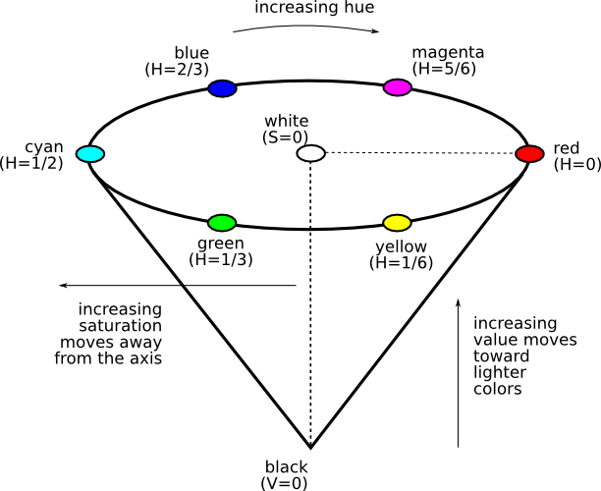

**Figure 15** : HSV Color space

## **15.3 Convert from RGB to HSV:**

In case of 8-bit images, R, G, and B are converted to the floating-point format and scaled to fit the 0 to 1 range.



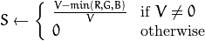

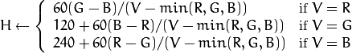

If  then  . On output , ,  .

For 8 bit image the output is



# **16 APPENDIX B. HARDWARE LIST**

|  |  |  |
| --- | --- | --- |
| Name | Quantity | Link of specification |
| V-Slot Rail-285-LP | 2 | <http://openbuildspartstore.com/v-slot-linear-rail/> |
| V-Slot Gantry Set | 1 | <http://openbuildspartstore.com/v-slot-gantry-set/> |
| Nema 17 Stepper Motor | 2 | <http://www.pbclinear.com/Download/DataSheet/Stepper-Motor-Support-Document.pdf> |
| GT2 Timing Belt-3 Feet | 2 | <http://www.york-ind.com/print_cat/york_2mmGT2.pdf> |
| GT2 Timing Pulley (30 Tooth) | 4 | <http://www.york-ind.com/print_cat/york_2mmGT2.pdf> |
| Micro Limit Switch (with mounting plate) | 2 | <http://openbuildspartstore.com/micro-limit-switch-kit-with-mounting-plate/> |
| Power HD High-Speed Mini Servo HD-1705MG | 2 | <https://www.pololu.com/product/2143> |
| SUNSKY S-360-12  Power Supply | 1 | <http://upload.sunsky-online.com/res/drivers/12V30A.pdf> |
| NEMA 17 Stepper Motor Mount | 2 | <https://www.pololu.com/product/2266> |
| Flexible Helical Coupling | 2 | <http://www.farnell.com/datasheets/43730.pdf> |
| Arduino Mega | 1 | <http://www.microelectronicos.com/datasheets/ArduinoMega2560.pdf> |
| RAMPS 1.4 Stepper Motor Shield | 1 | <http://reprap.org/wiki/RAMPS_1.4> |
| A4988 Stepper Motor Driver  (with heatsink) | 2 | <http://www.robotshop.com/media/files/PDF/datasheet-1182.pdf> |
| 2004 LCD Control Board | 1 | <http://www.farnell.com/datasheets/58820.pdf> |
| Mini Pushbutton Switch | 1 | <http://www.farnell.com/datasheets/1658379.pdf> |
| Resistor(1K) | 1 | <http://www.petervis.com/electronics/Standard_Resistor_Values/1K0.html> |
| PLAYSTATION Eye**™** | 1 | <https://www.playstation.com/manual/pdf/CEJH15001.pdf> |
| LM2596 DC-DC Converter | 1 | <http://www.aliexpress.com/item/DC-DC-Buck-Converter-Step-Down-Module-LM2596-Power-Supply-Output-1-23V-30V/846265709.html> |

**Table 15.** Hardware List

# **17 APPENDIX C. FIGURE LIST**

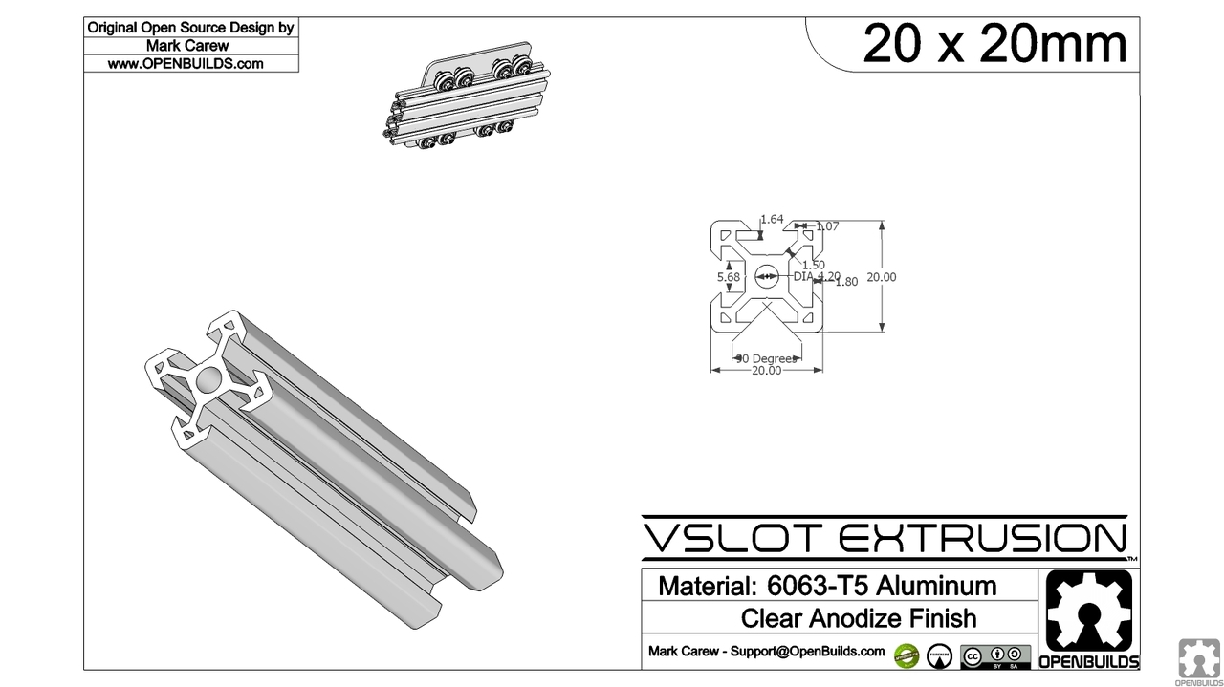

**Figure 16.** V-Slot Rail

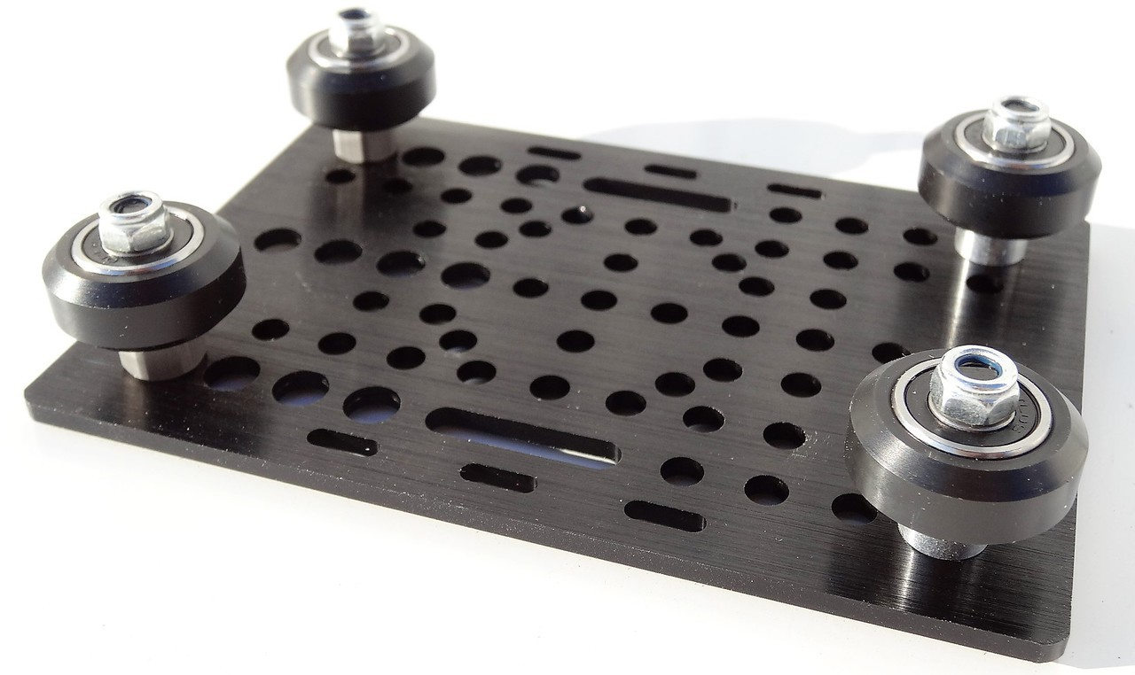

**Figure 17.** V-Slot Gantry Set

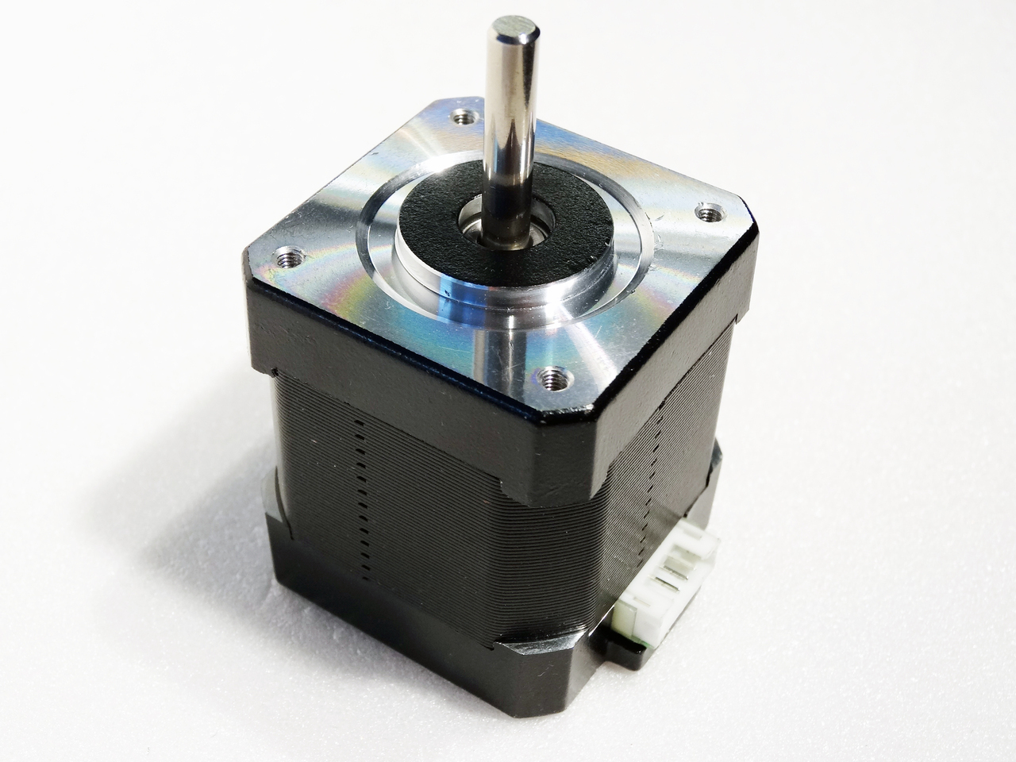

**Figure 18.** Nema 17 Stepper Motor

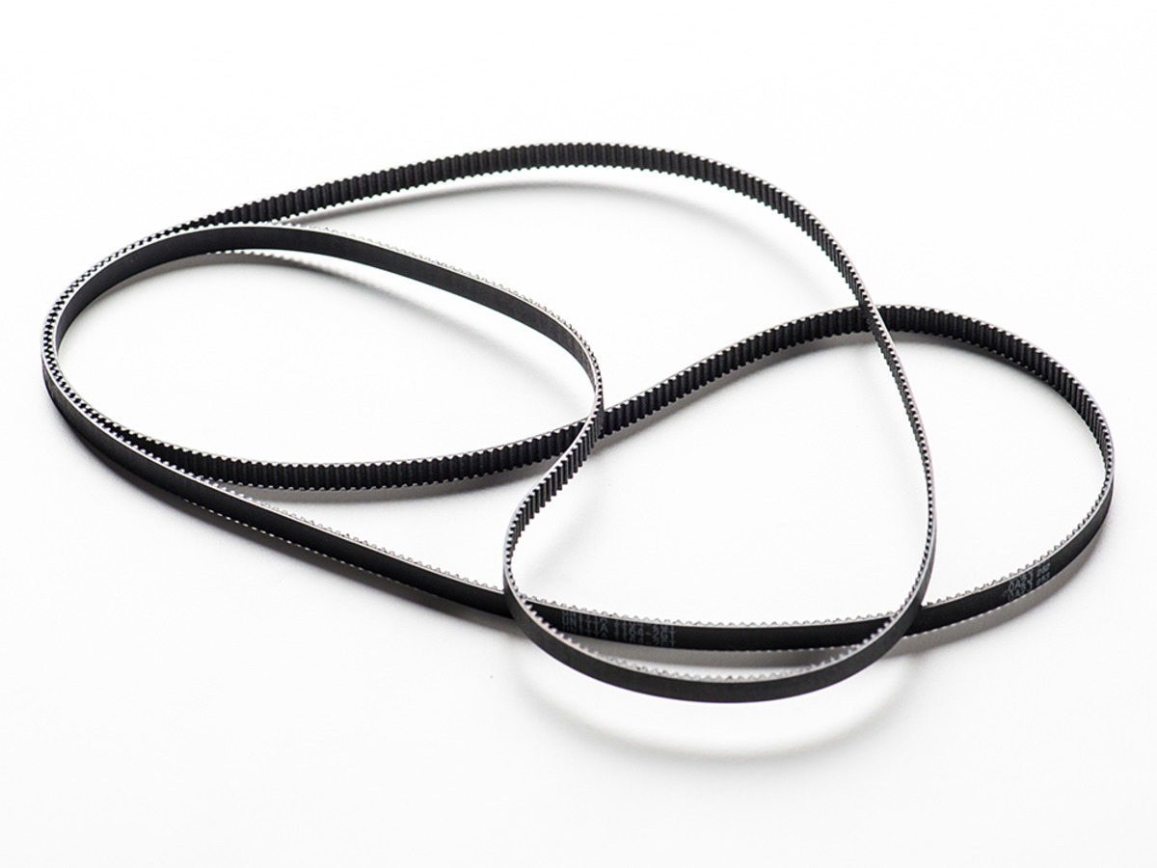

**Figure 19.** GT2 Timing Belt

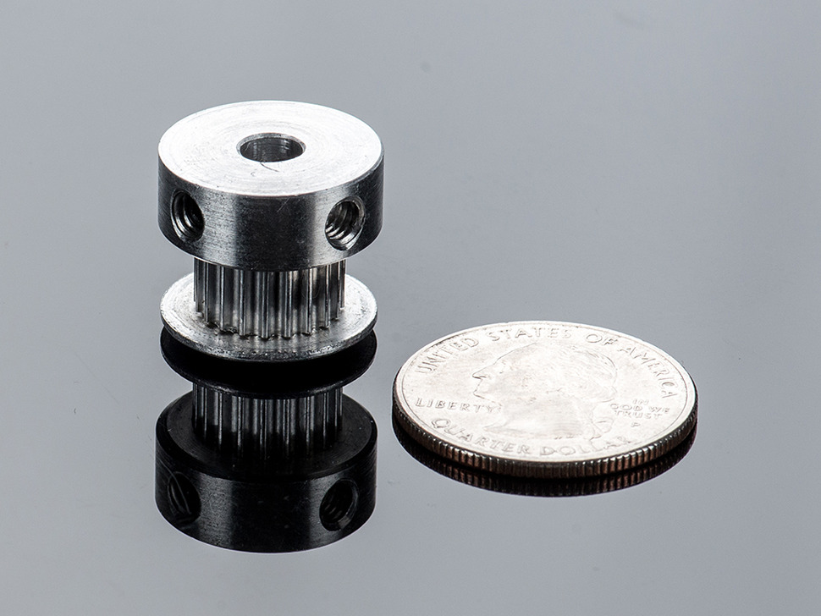

**Figure 20.** GT2 Timing Pulley

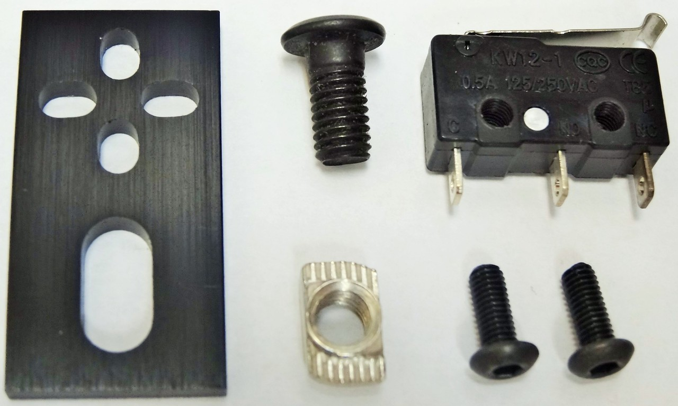

**Figure 21.** Micro Limit Switch (with mounting plate)

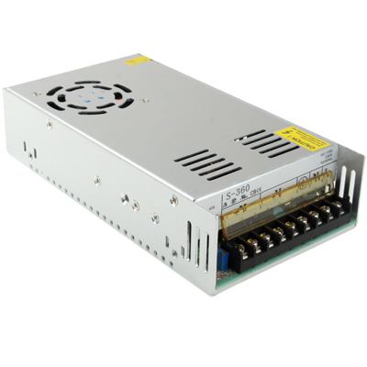

**Figure 22.** SUNSKY S-360-12 Power Supply

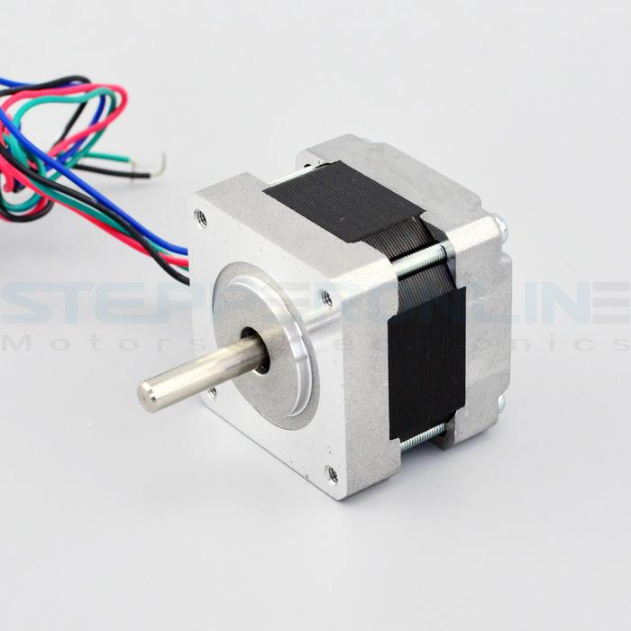

**Figure 23.** Nema 16 Stepper Motor

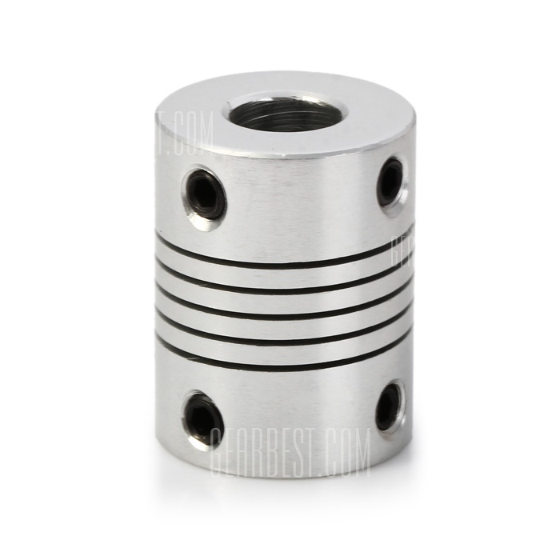

**Figure 24.** Flexible Helical Coupling

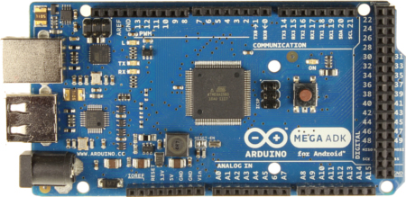

**Figure 25.**.Arduino Mega

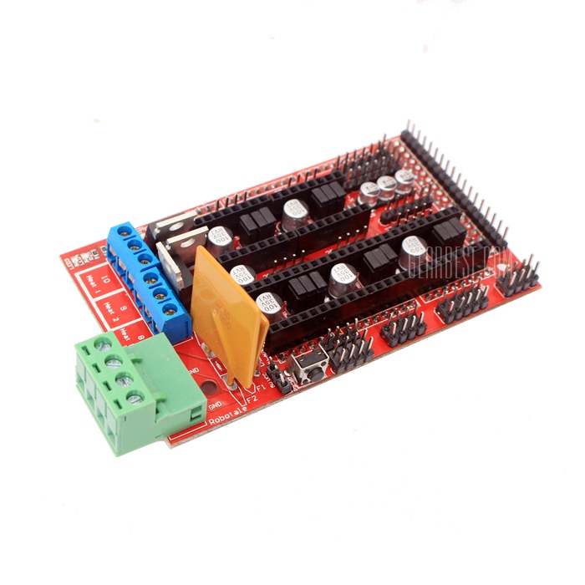

**Figure 26.** RAMPS 1.4 Stepper Motor Shield

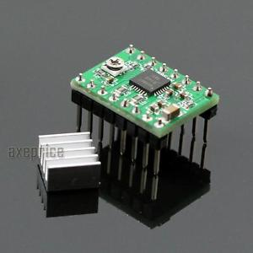

**Figure 27.** A4988 Stepper Motor Driver

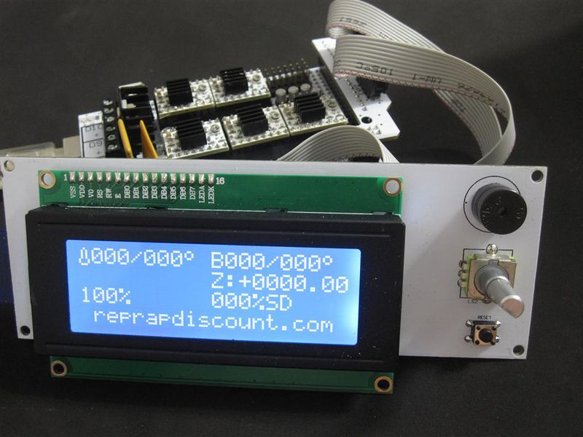

**Figure 28.** 2004 LCD Control Board

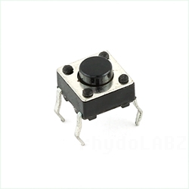

**Figure 29.** Mini Pushbutton Switch

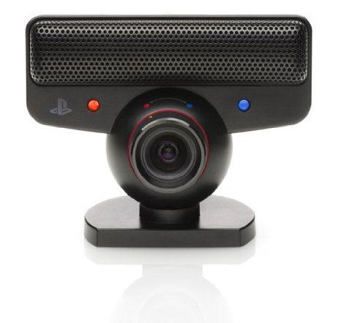

**Figure 30.** PLAYSTATION Eye**™**

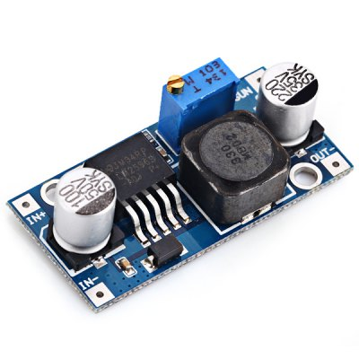

**Figure 31.** LM2596 DC-DC converter

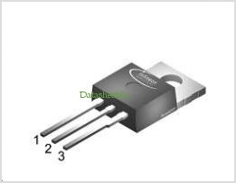

**Figure 32.** BUZ73AH N-Mosfet

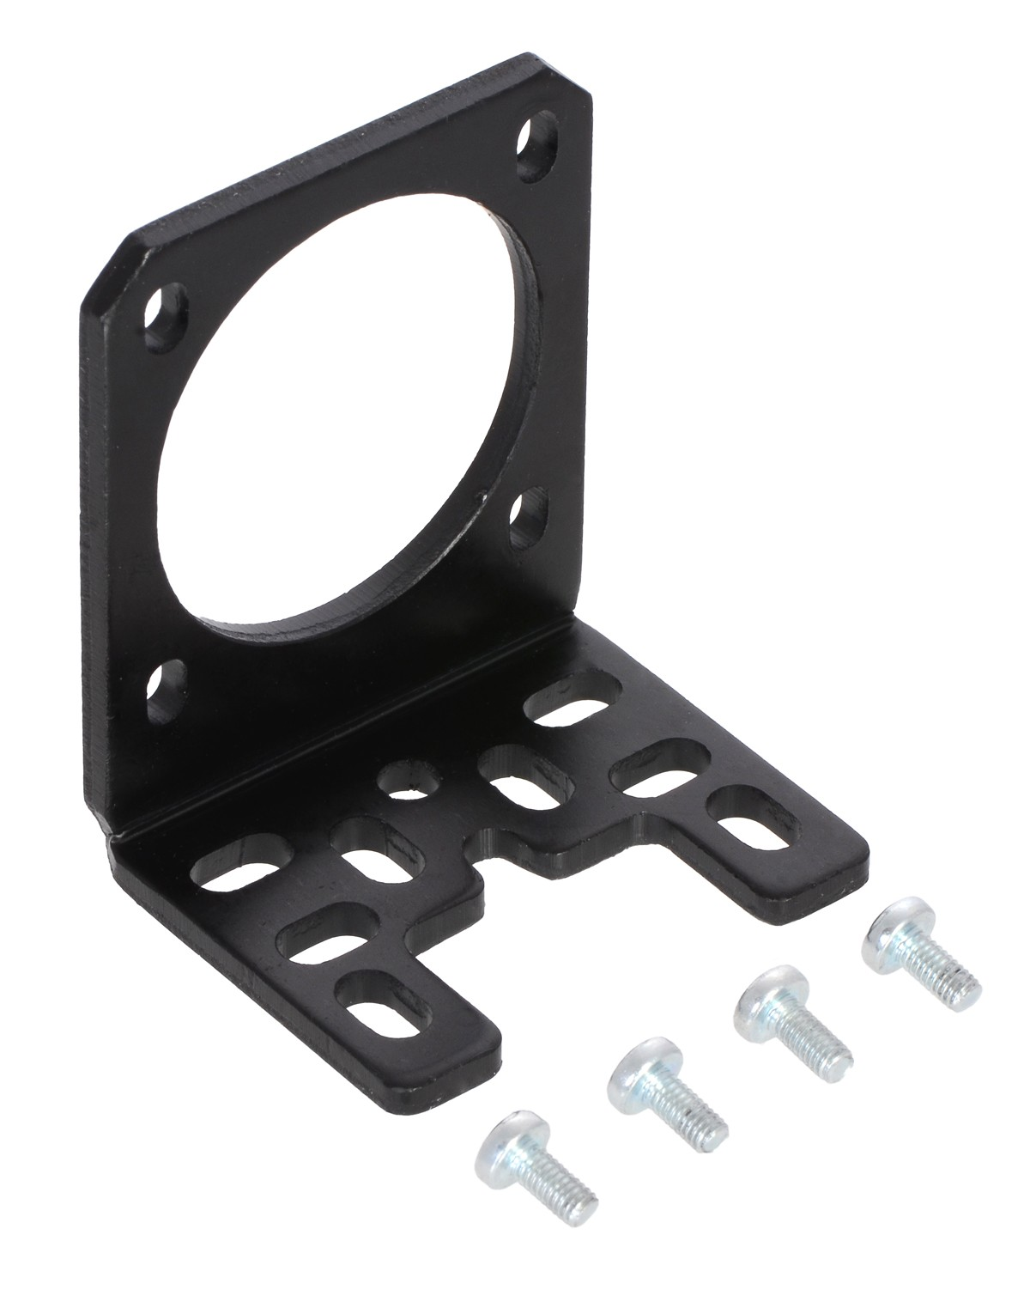

**Figure 33**. Nema 17 Stepper Motor Mount